




UniversityCollegeofEngineering,Thirukkuvalai
DepartmentofComputerScienceAndEngineering

Completedtheprojectnamedas

LaptopRequestCatalog Item

TeamID:NM2025TMID03628

TeamSize:4

Team Leader : Joshitha R [822222104015] Teammember1:Bhavani M[822222104044] Teammember2:BavithraV[822222104024] Team member 3 :Abinaya J [822222104014]

Abstract

The Laptop Request Catalog Item project successfully automated and simplified the organizational laptop request process using ServiceNow.
This solution replaced the slow, error-prone manual system with a dynamic Service Catalog Item. Key features, including dynamic form fields, reset functionality, and clear user guidance, were implemented using UI Policies and UI Actions to ensure data accuracy and enhanced interactivity.
The result is a streamlined workflow that delivers improved efficiency, reduced errors, and significantly higher employee satisfaction. Deployment was managed smoothly using update sets.
.

Introduction
Efficient IT service management is crucial for modern organizational productivity. A key challenge is the manual, email-based management of hardware requests, such as laptops, which often causes delays, data gaps, and poor tracking. This inefficiency negatively impacts both IT staff and employees.
To solve this, ServiceNow was chosen as the ideal platform. As a powerful, cloud-based ITSM tool, ServiceNow allows organizations to automate workflows and manage service requests efficiently. Its Service Catalog feature enables the creation of interactive forms with dynamic behavior, ensuring accurate data collection and rapid processing. ServiceNow's capabilities in customization, workflow automation, and deployment management made it the perfect choice to streamline the laptop request process.
ThemainobjectivesoftheLaptopRequestCatalogItemprojectare:

- Toautomateandstreamlinethelaptoprequestprocess.
- Tocreateadynamicanduser-friendlyServiceCatalogItem.
- ToensureaccuratedatacollectionthroughUIPoliciesandUIActions.
- Toimplementreset functionalityforeaseofuse.
- Toenableefficienttrackinganddeploymentusingupdate sets.

Overall,thisprojectaimstoenhancetheemployeeexperience,reducemanualeffort,andimprovethe efficiency of IT service delivery within the organization.

ProblemStatement
Inmanyorganizations,employeesrelyonmanualoremail-basedprocessestorequestlaptopsandother IT assets. This traditional approach is time-consuming, error-prone, andlacks transparency. The absence of an automated system often leads to
miscommunicationbetweenemployeesandtheITdepartment,resultingindelaysinrequestapprovals, incomplete information, and difficulty in tracking request statuses.

Moreover,themanualprocessprovidesnodynamicformbehaviortoguideusers,causinginconsistent data entry and additional workload for IT administrators who must verify and correct information manually. There is also a lack of centralized visibility into requests, making it challenging for management to monitor progress, ensure compliance, or generate reports for governance purposes.
The Laptop Request Catalog Item project aims to resolve these challenges by developing an automated Service Catalog Item within the ServiceNow platform. This solution introduces dynamic forms, automatedworkflows,andtrackingcapabilitiestoensurefasterprocessing,accuratedatacollection,and enhanced visibility of laptop requests across the organization.

SystemDesign/ Methodology

DesignApproach
The design of the Laptop Request Catalog Item follows a user-centric and modular approach to ensure simplicity,automation,andscalability.Themaingoalistostreamlinethelaptoprequestprocessthrough a structured, interactive, and efficient digital workflow. The design emphasizes easy usability for end users and seamless management for administrators.
KeyServiceNowfeaturesandmodulesusedinthisprojectinclude:

  - ServiceCatalog:TocreatetheLaptopRequestitemwhereemployeescansubmittheirrequests using predefined fields and options.
  - CatalogUIPolicies:Todynamicallyshow,hide,ormakeformfieldsmandatorybasedonuser selections, ensuring accurate data entry.
  - UIActions:Toimplementinteractivebuttons,suchastheResetFormbutton,whichclearsthe inputs for a better user experience.
  - UpdateSetManagement:Tocaptureallconfigurationchangesandenablesmoothmigrationof the catalog item between ServiceNow instances.
  - ServiceNowStudio:Todevelop,organize,andmanagescripts,forms,andconfigurations efficiently within the platform.
Thisdesignapproachensuresautomation,reduceshumanintervention,andprovidestransparency throughout the request lifecycle.

SystemArchitecture
The Laptop Request Catalog Item system is built within the ServiceNow platform, leveraging its modularandcloud-basedarchitecture.ThesolutionintegratesmultipleServiceNowcomponentsto deliver a cohesive workflow:
  - UserInterfaceLayer: EmployeesaccesstheServiceCatalogPortaltofillout andsubmitthe
LaptopRequestform.

  - Business Logic Layer: UI Policies and Client Scripts dynamically control form behavior and validations, ensuring users input correct and complete information. ProcessAutomation Layer: Submitted requests are automatically logged in the ServiceNow Request Management
module,triggeringapprovalworkflowsand notifications.
  - DataStorageLayer:Allrequests,configurations,andlogsaresecurelystoredintheServiceNow database for tracking, auditing, and reporting.
  - Integration and Deployment: Using Update Sets, the developed catalog item and its configurationscanbeexportedandimportedacrossdifferentServiceNowinstances,ensuring deployment consistency.
Thislayeredarchitectureensuresthatthesystemisscalable,easilymaintainable,andalignedwithIT service management best practices.

UserInterface(UI)andUserExperience(UX)
TheLaptopRequestformisdesignedtobeintuitive,visuallyclear,andresponsive,providinguserswith a smooth interaction experience. The form layout includes essential fields such as Laptop Model, Justification, and Additional Accessories, organized in a logical order for easy completion.
KeyUI/UXconsiderations:

  - DynamicFieldBehavior:Fieldsappearorbecomemandatorybasedontheuser’sselection(e.g., additional accessories).
  - ResetFormButton:ImplementedthroughaUIActionscript,allowinguserstoclearallentries instantly and start over.
  - ClearInstructions:Each sectionprovidesguidancetohelpusersfillincorrect details.
  - ConsistentLayout:TheformfollowsacleanandminimaldesignusingServiceNow’snativeUI framework for a professional look.
  - FeedbackandAlerts:Popupalertsconfirmactionssuchasresettingtheform,enhancingclarity and confidence for users. The overall UX design ensures that employees can submit laptop requestsquicklyandaccuratelywhilemaintainingamodernandefficientinterfacealignedwith ServiceNow’s best practices.
ImplementationDetails

PlatformSetup
TheLaptopRequestCatalogItemprojectwasdevelopedontheServiceNowplatform,whichprovidesa cloud-based environment for IT service management and workflow automation. The initial setup involved requesting and configuring a ServiceNow developer instance to serve as the development and testing environment.
Keystepsinthesetupincluded:

InstanceConfiguration:

    - AnewServiceNow developer instance was provisioned. oDefault modules were reviewed,andnecessaryplugins(ServiceCatalogandRequestManagement)were activated.

UserandGroupCreation:
    - Administrativeroleswereassignedforproject development andconfiguration tasks. o UserrolessuchasRequester,Approver,andITAdministratorwerecreatedtosimulate real organizational workflows.
    - Groupswereconfiguredformanagingapprovalandfulfillment processes.

AccessManagement:
    - Permissionswereconfiguredtoensurethatonlyauthorizeduserscouldcreate,view,or approve laptop requests.

Thisinitialconfigurationensuredthatallprojectmemberscouldcollaborativelydesign,test,and validate the Service Catalog item in a controlled and secure environment.

DevelopmentandCustomization
The development phase focused on creating and customizing the Laptop Request Catalog Item to meet businessrequirements.Theprocessinvolveddesigningforms,addingdynamicbehaviors,andenabling automation features to simplify user interactions.

Keydevelopmentactivitiesincluded:

  - CatalogItemCreation:
    - AnewLaptopRequestcatalogitem wascreatedundertheServiceCatalogmodule.
    - InputfieldssuchasLaptopModel,Justification,AdditionalAccessories,andAccessories Details were added as catalog variables.

CustomScripts:
    - Client-sidescriptsweredevelopedusingJavaScripttoenhanceformbehaviorand provide interactivity.
    - AcustomUIActionscriptwasimplementedfortheResetFormbuttontoclearallform inputs dynamically.

UIPoliciesand Conditions:
    - CatalogUIPolicieswereconfiguredtoshoworhidefieldsbasedonuserselections(e.g., displaying accessory details only if additional accessories are selected).
    - Mandatoryfieldconditionsensuredcompleteandaccuratedatacollection.

UpdateSet Management:
    - AllconfigurationsandscriptsweretrackedusingLocalUpdateSetstocapture development changes and facilitate migration to other ServiceNow instances.

Throughthesecustomizations,theprojectachievedadynamicandinteractiveServiceCatalogitem aligned with organizational needs.

WorkflowImplementation

Theworkflowimplementationwasacriticalpartofautomatingthelaptoprequestprocessandensuring that requests follow a structured path from submission to fulfillment.

Workflowdesignandmanagementincluded:

  - WorkflowCreation:
    - Acustomworkflowwas designedusingtheFlowDesignerinServiceNow.
    - TheworkflowbeginswhenausersubmitsaLaptopRequestformfromtheService Catalog.

ApprovalandNotificationStages:
    - Theworkflowautomaticallyroutestherequesttotheassignedapprover(managerorIT administrator).
    - Notificationemailsaretriggeredtoinformboththerequesterandtheapproveraboutthe request status. Fulfillment Process:
    - Onceapproved,theITdepartmentisnotifiedtoallocateandconfiguretherequested
laptop.
    - TheworkflowupdatestherequeststatustoInProgressandlatertoClosedupon completion.

Changeand Tracking:
    - Allworkflowactivitiesareloggedinthesystem,ensuringtraceabilityandaccountability.
      - Administratorscanmonitorworkflowexecution,identifybottlenecks,andgenerate reports for governance.

Thisworkflowautomationeliminatesmanualfollow-ups,enhancesvisibility,andensurestimely fulfillment of laptop requests within the organization.
Setup Steps

Step1:CreateLocalUpdateSet

CreateanewlocalupdatesetinServiceNowtotrackallyour changes.

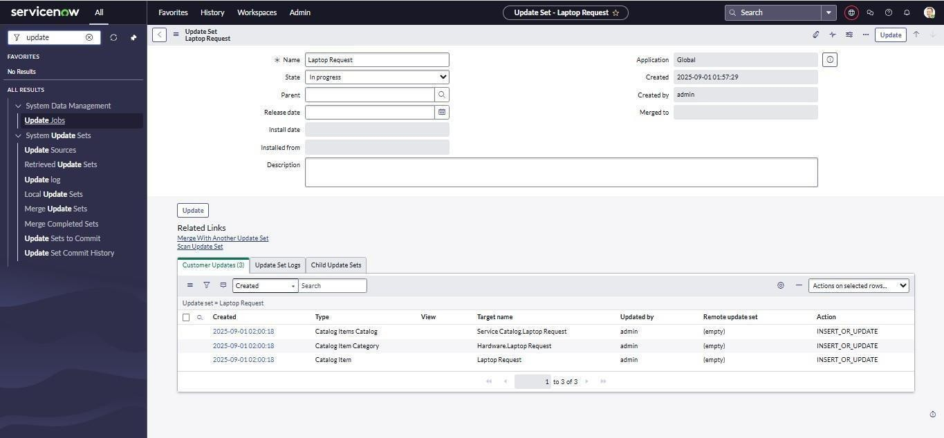

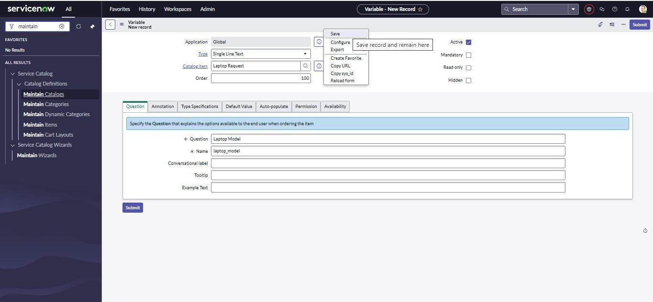

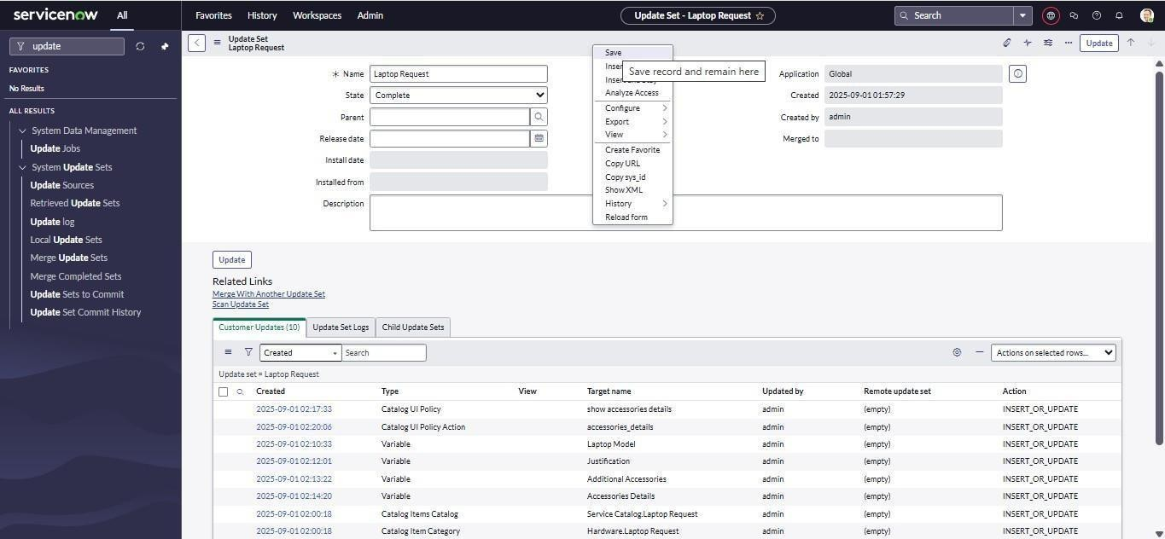

Step2:CreateService Catalog Item
CreateacatalogitemnamedLaptopRequestandaddrequiredvariablessuchas: Laptop Model
Justification
AdditionalAccessories Accessories Details

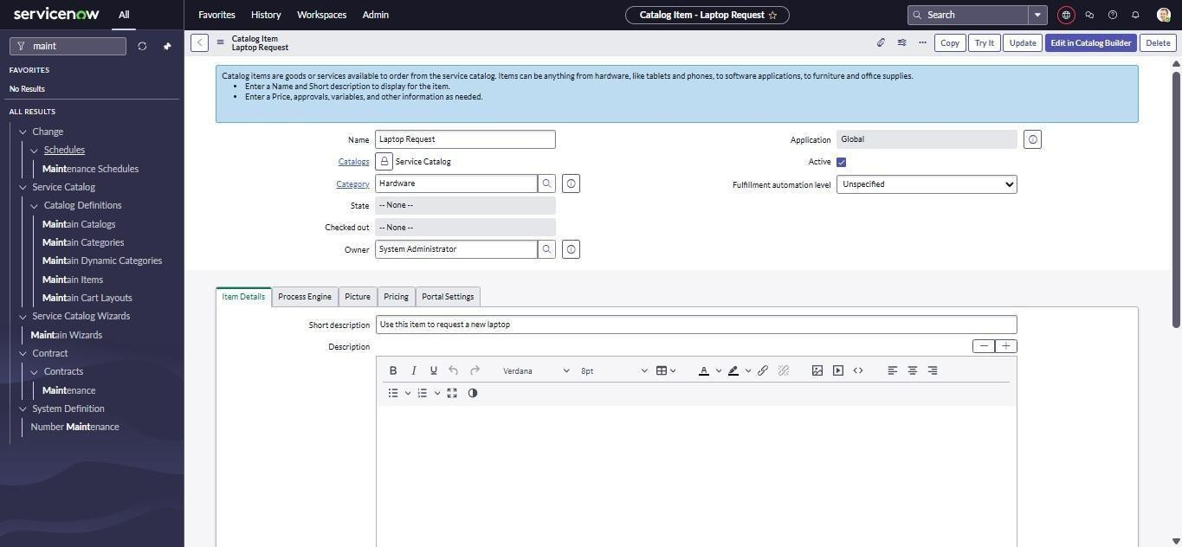

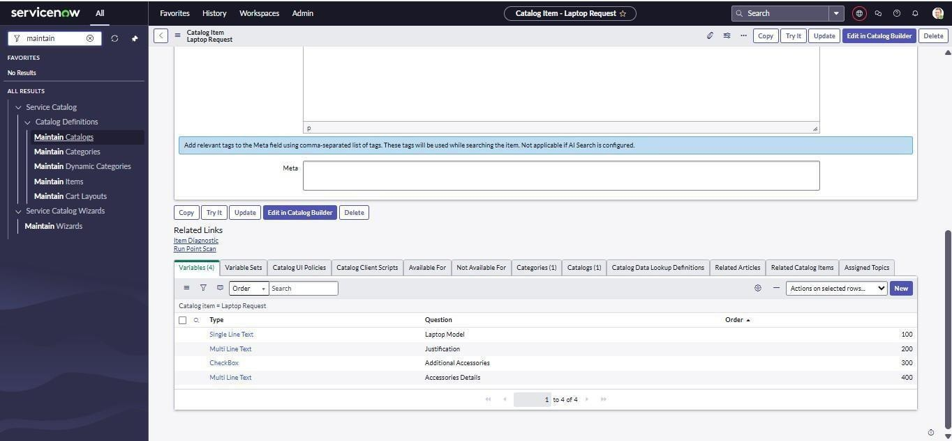

Step3:AddCatalogUIPoliciesCreateUI policies to:
Show/hidefieldsbasedonselections Makefieldsmandatorydynamically

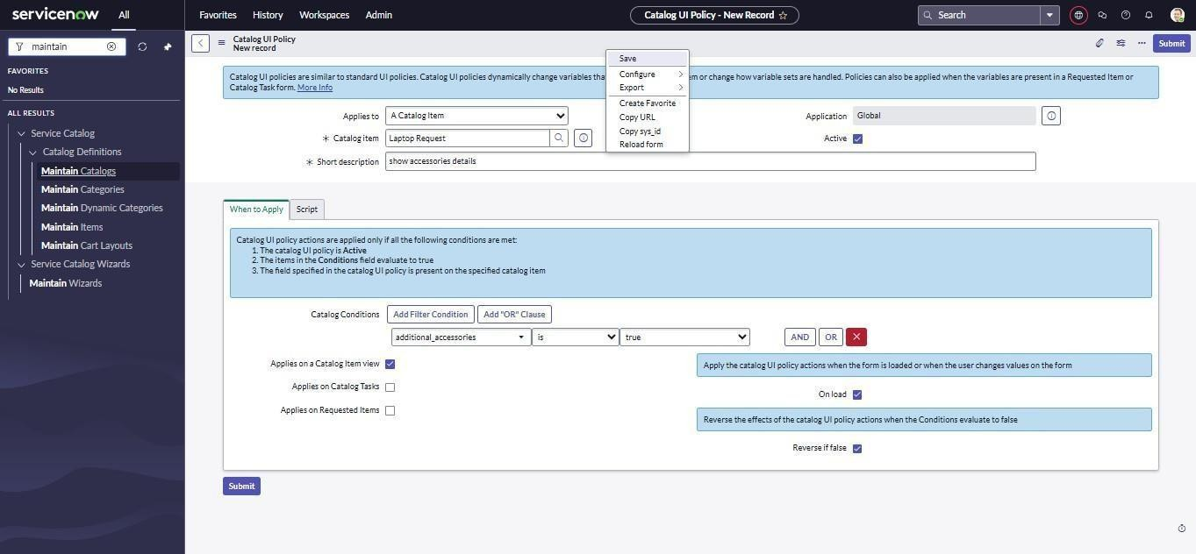

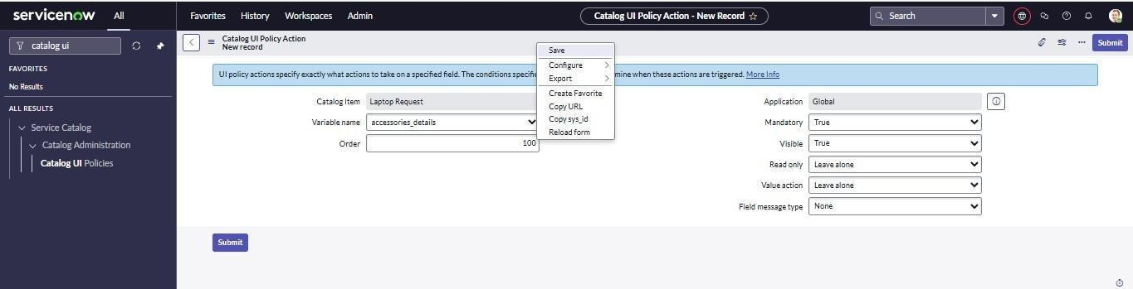

Step4:CreateUIAction(ResetForm)
AddaResetFormbuttonusingaclient-sideUIActiontocleartheforminputs.Step5:UI Action Create 1. Open service now.
- ClickonAll >>search forui action
- Selectuiactionsundersystem definition
- Clickon new
- Fillthefollowingdetailstocreateuiaction Table: shopping cart(sc_cart)
Order:100
Action name: Reset form Client : checked Script:
functionresetForm(){
g_form.clearForm();//Clearsallfieldsintheformalert("Theformhas been reset.");
}
Clickon save
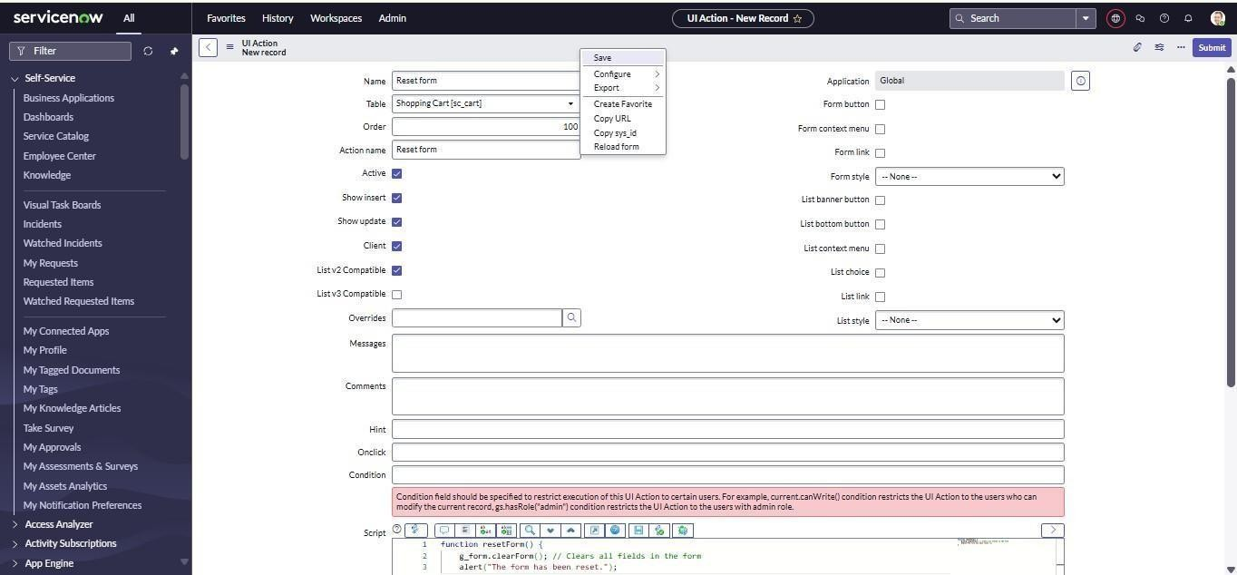

Step5:Export Changes

Exporttheupdate setto anXMLfileforreusein otherServiceNowinstances.
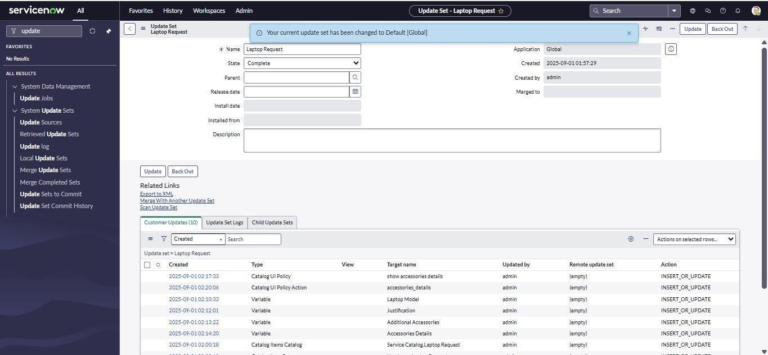

Step6:ImporttoAnotherInstance

LogintoadifferentServiceNowinstanceandretrievetheupdate.

ExportedXMLfileProgram:

<?xmlversion="1.0"encoding="UTF-8"?><unloadunload_date="2025-10-2709:41:33">
<sys_remote_update_setaction="INSERT_OR_UPDATE">
<applicationdisplay_value="Global">global</application>
<application_name>Global</application_name>
<application_scope>global</application_scope>
<application_version/>
<collisions/>
<commit_date/>
<deleted/>
<description/>
<inserted/>
<name>LaptopRequest</name>
<origin_sys_id/>
<parentdisplay_value=""/>
<release_date/>
<remote_base_update_setdisplay_value=""/>
<remote_parent_id/>
<remote_sys_id>4422c61a83f43210aa085855eeaad365</remote_sys_id>
<state>loaded</state>
<summary/>
<sys_class_name>sys_remote_update_set</sys_class_name>
<sys_created_by>admin</sys_created_by>
<sys_created_on>2025-10-2709:41:32</sys_created_on>
<sys_id>83ea025a83383210aa085855eeaad328</sys_id>
<sys_mod_count>0</sys_mod_count>
<sys_updated_by>admin</sys_updated_by>
<sys_updated_on>2025-10-2709:41:32</sys_updated_on>
<update_setdisplay_value=""/>
<update_sourcedisplay_value=""/>
<updated/>
</sys_remote_update_set>
<sys_update_xmlaction="INSERT_OR_UPDATE">
<action>INSERT_OR_UPDATE</action>
<applicationdisplay_value="Global">global</application>
<category>customer</category>
<comments/>
<name>sc_cat_item_category_01a3c6da83f43210aa085855eeaad345</name>
<payload><![CDATA[<?xml version="1.0" encoding="UTF-8"?><record_update table="sc_cat_item_category"><sc_cat_item_category action="INSERT_OR_UPDATE"><sc_cat_item display_value=" Laptop Request">76b2ca5a83f43210aa085855eeaad300</sc_cat_item><sc_category display_value="Hardware">d258b953c611227a0146101fb1be7c31</sc_category><sys_class_name>sc_cat_item
_category</sys_class_name><sys_created_by>admin</sys_created_by><sys_created_on>2025-10-27 09:09:43</sys_created_on><sys_id>01a3c6da83f43210aa085855eeaad345</sys_id><sys_mod_count>0</sys_m od_count><sys_name>Hardware. Laptop Request</sys_name><sys_package display_value="Global"source="global">global</sys_package><sys_policy/><sys_scope display_value="Global">global</sys_scope><sys_update_name>sc_cat_item_category_01a3c6da83f43210aa085

855eeaad345</sys_update_name><sys_updated_by>admin</sys_updated_by><sys_updated_on>2025-10-27 09:09:43</sys_updated_on></sc_cat_item_category></record_update>]]></payload>
<payload_hash>-597637923</payload_hash>
<remote_update_set display_value="Laptop Request">83ea025a83383210aa085855eeaad328</remote_update_set>
<replace_on_upgrade>false</replace_on_upgrade>
<sys_created_by>admin</sys_created_by>
<sys_created_on>2025-10-2709:41:32</sys_created_on>
<sys_id>13ea8a5a83383210aa085855eeaad315</sys_id>
<sys_mod_count>0</sys_mod_count>
<sys_recorded_at>19a24ee3a3b0000001</sys_recorded_at>
<sys_updated_by>admin</sys_updated_by>
<sys_updated_on>2025-10-2709:41:32</sys_updated_on>
<table/>
<target_name>Hardware.LaptopRequest</target_name>
<type>CatalogItemCategory</type>
<update_domain>global</update_domain>
<update_guid>8da3c6da64f432109c7e4ec1d69c954a</update_guid>
<update_guid_history>8da3c6da64f432109c7e4ec1d69c954a:-597637923</update_guid_history>
<update_setdisplay_value=""/>
<view/>
</sys_update_xml>
<sys_update_xmlaction="INSERT_OR_UPDATE">
<action>INSERT_OR_UPDATE</action>
<applicationdisplay_value="Global">global</application>
<category>customer</category>
<comments/>
<name>item_option_new_6466ce1e83f43210aa085855eeaad376</name>
<payload>&lt;?xml version="1.0" encoding="UTF-8"?&gt;&lt;record_update table="item_option_new"&gt;&lt;item_option_new action="INSERT_OR_UPDATE"&gt;&lt;active&gt;true&lt;/active&gt;&lt;attributes/&gt;&lt;cat_item display_value=" Laptop Request"&gt;76b2ca5a83f43210aa085855eeaad300&lt;/cat_item&gt;&lt;category/&gt;&lt;choice_direction&gt;d own&lt;/choice_direction&gt;&lt;choice_field/&gt;&lt;choice_table/&gt;&lt;conversational_label/&gt;&lt;create
_roles/&gt;&lt;default_html_value/&gt;&lt;default_value/&gt;&lt;delete_roles/&gt;&lt;delivery_plan/&gt;&lt;de scription/&gt;&lt;disable_initial_slot_fill&gt;false&lt;/disable_initial_slot_fill&gt;&lt;display_title&gt;false&lt;/ display_title&gt;&lt;do_not_select_first&gt;false&lt;/do_not_select_first&gt;&lt;dynamic_default_value/&gt;&lt
;dynamic_ref_qual/&gt;&lt;dynamic_value_dot_walk_path/&gt;&lt;dynamic_value_field/&gt;&lt;enable_also_re quest_for&gt;false&lt;/enable_also_request_for&gt;&lt;example_text/&gt;&lt;field/&gt;&lt;global&gt;false&lt;/ global&gt;&lt;help_tag&gt;More information&lt;/help_tag&gt;&lt;help_text/&gt;&lt;hidden&gt;false&lt;/hidden&gt;&lt;include_none&gt;false&l t;/include_none&gt;&lt;instructions/&gt;&lt;layout&gt;normal&lt;/layout&gt;&lt;list_table/&gt;&lt;lookup_depe ndent_question/&gt;&lt;lookup_label/&gt;&lt;lookup_price/&gt;&lt;lookup_source/&gt;&lt;lookup_table/&gt;&l t;lookup_unique&gt;false&lt;/lookup_unique&gt;&lt;lookup_value/&gt;&lt;macro/&gt;&lt;macroponent/&gt;&lt
;mandatory&gt;false&lt;/mandatory&gt;&lt;map_to_field&gt;false&lt;/map_to_field&gt;&lt;mask_use_confirma tion&gt;false&lt;/mask_use_confirmation&gt;&lt;mask_use_encryption&gt;false&lt;/mask_use_encryption&gt; &lt;name&gt;accessories_details&lt;/name&gt;&lt;not_available_conversation&gt;false&lt;/not_available_conve rsation&gt;&lt;order&gt;400&lt;/order&gt;&lt;post_insert_script/&gt;&lt;price_if_checked&gt;0&lt;/price_if_ch ecked&gt;&lt;pricing_implications&gt;false&lt;/pricing_implications&gt;&lt;published_ref/&gt;&lt;question_tex

t&gt;Accessories Details&lt;/question_text&gt;&lt;read_only&gt;false&lt;/read_only&gt;&lt;read_roles/&gt;&lt;read_script/&gt;& lt;rec_lookup_price/&gt;&lt;rec_price_if_checked&gt;0&lt;/rec_price_if_checked&gt;&lt;record/&gt;&lt;record_ producer_table/&gt;&lt;reference/&gt;&lt;reference_qual/&gt;&lt;reference_qual_condition/&gt;&lt;rich_text/&gt;&lt;roles_to_use_also_request_for/&gt;&lt;save_script&gt;&lt;![CDATA[/**Thisscriptisexecutedbeforethe Record is generated
- `current`-GlideRecordproducedbyRecordProducer
- Don'tuse`current.update()`or`current.insert()`astherecordisgeneratedbyRecordProducer
- Don'tuse`current.setValue('sys_class_name','xxx')`asthiswilltriggerreparentflowandcancausedataloss
- Avoid`current.setAbortAction()`andgenerateaseparaterecord
- Use`producer.var1`toaccessvariables
*/]]&gt;&lt;/save_script&gt;&lt;scale_max&gt;5&lt;/scale_max&gt;&lt;scale_min&gt;0&lt;/scale_min&gt;&lt;s how_help&gt;false&lt;/show_help&gt;&lt;show_help_on_load&gt;false&lt;/show_help_on_load&gt;&lt;sp_wid get/&gt;&lt;summary_macro/&gt;&lt;sys_class_name&gt;item_option_new&lt;/sys_class_name&gt;&lt;sys_crea ted_by&gt;admin&lt;/sys_created_by&gt;&lt;sys_created_on&gt;2025-10-27 09:22:00&lt;/sys_created_on&gt;&lt;sys_id&gt;6466ce1e83f43210aa085855eeaad376&lt;/sys_id&gt;&lt;sys_mo d_count&gt;0&lt;/sys_mod_count&gt;&lt;sys_name&gt;AccessoriesDetails&lt;/sys_name&gt;&lt;sys_package display_value="Global" source="global"&gt;global&lt;/sys_package&gt;&lt;sys_policy/&gt;&lt;sys_scope display_value="Global"&gt;global&lt;/sys_scope&gt;&lt;sys_update_name&gt;item_option_new_6466ce1e83f4 3210aa085855eeaad376&lt;/sys_update_name&gt;&lt;sys_updated_by&gt;admin&lt;/sys_updated_by&gt;&lt;sy s_updated_on&gt;2025-10-27 09:22:00&lt;/sys_updated_on&gt;&lt;table/&gt;&lt;tooltip/&gt;&lt;topic_block/&gt;&lt;type&gt;2&lt;/type&gt; &lt;ui_page/&gt;&lt;unique&gt;false&lt;/unique&gt;&lt;use_dynamic_default&gt;false&lt;/use_dynamic_default &gt;&lt;use_reference_qualifier&gt;simple&lt;/use_reference_qualifier&gt;&lt;validate_regex/&gt;&lt;variable_ name/&gt;&lt;variable_set/&gt;&lt;variable_width/&gt;&lt;visibility&gt;1&lt;/visibility&gt;&lt;visible_bundle& gt;true&lt;/visible_bundle&gt;&lt;visible_guide&gt;true&lt;/visible_guide&gt;&lt;visible_standalone&gt;true&lt;
/visible_standalone&gt;&lt;visible_summary&gt;true&lt;/visible_summary&gt;&lt;write_roles/&gt;&lt;/item_opt ion_new&gt;&lt;sys_translated_text action="delete_multiple" query="documentkey=6466ce1e83f43210aa085855eeaad376"/&gt;&lt;fx_price action="delete_multiple"query="id=6466ce1e83f43210aa085855eeaad376"/&gt;&lt;fx_price action="INSERT_OR_UPDATE"&gt;&lt;amount&gt;0&lt;/amount&gt;&lt;currency display_value="USD"&gt;USD&lt;/currency&gt;&lt;field&gt;price_if_checked&lt;/field&gt;&lt;id&gt;6466ce1e 83f43210aa085855eeaad376&lt;/id&gt;&lt;parent/&gt;&lt;reference_amount&gt;0&lt;/reference_amount&gt;&lt
;reference_currency display_value="USD"&gt;USD&lt;/reference_currency&gt;&lt;sys_created_by&gt;admin&lt;/sys_created_by&g t;&lt;sys_created_on&gt;2025-10-27 09:22:00&lt;/sys_created_on&gt;&lt;sys_id&gt;4176425283383210aa085855eeaad3a8&lt;/sys_id&gt;&lt;sys_m od_count&gt;0&lt;/sys_mod_count&gt;&lt;sys_updated_by&gt;admin&lt;/sys_updated_by&gt;&lt;sys_updated_ on&gt;2025-10-27 09:22:00&lt;/sys_updated_on&gt;&lt;table&gt;item_option_new&lt;/table&gt;&lt;type&gt;calculated&lt;/type& gt;&lt;/fx_price&gt;&lt;fx_price action="INSERT_OR_UPDATE"&gt;&lt;amount&gt;0&lt;/amount&gt;&lt;currency display_value="USD"&gt;USD&lt;/currency&gt;&lt;field&gt;rec_price_if_checked&lt;/field&gt;&lt;id&gt;6466 ce1e83f43210aa085855eeaad376&lt;/id&gt;&lt;parent/&gt;&lt;reference_amount&gt;0&lt;/reference_amount&g t;&lt;reference_currency display_value="USD"&gt;USD&lt;/reference_currency&gt;&lt;sys_created_by&gt;admin&lt;/sys_created_by&g t;&lt;sys_created_on&gt;2025-10-27 09:22:00&lt;/sys_created_on&gt;&lt;sys_id&gt;0176425283383210aa085855eeaad3a7&lt;/sys_id&gt;&lt;sys_m od_count&gt;0&lt;/sys_mod_count&gt;&lt;sys_updated_by&gt;admin&lt;/sys_updated_by&gt;&lt;sys_updated_

on&gt;2025-10-27 09:22:00&lt;/sys_updated_on&gt;&lt;table&gt;item_option_new&lt;/table&gt;&lt;type&gt;calculated&lt;/type&gt;&lt;/fx_price&gt;&lt;/record_update&gt;</payload>
<payload_hash>-379636007</payload_hash>
<remote_update_set display_value="Laptop Request">83ea025a83383210aa085855eeaad328</remote_update_set>
<replace_on_upgrade>false</replace_on_upgrade>
<sys_created_by>admin</sys_created_by>
<sys_created_on>2025-10-2709:41:32</sys_created_on>
<sys_id>1fea8a5a83383210aa085855eeaad313</sys_id>
<sys_mod_count>0</sys_mod_count>
<sys_recorded_at>19a24f979140000001</sys_recorded_at>
<sys_updated_by>admin</sys_updated_by>
<sys_updated_on>2025-10-2709:41:32</sys_updated_on>
<table/>
<target_name>AccessoriesDetails</target_name>
<type>Variable</type>
<update_domain>global</update_domain>
<update_guid>41764252ff3832102e3e3f76756d0eac</update_guid>
<update_guid_history>41764252ff3832102e3e3f76756d0eac:-379636007</update_guid_history>
<update_setdisplay_value=""/>
<view/>
</sys_update_xml>
<sys_update_xmlaction="INSERT_OR_UPDATE">
<action>INSERT_OR_UPDATE</action>
<applicationdisplay_value="Global">global</application>
<category>customer</category>
<comments/>
<name>catalog_ui_policy_action_1bd7cad283383210aa085855eeaad3c1</name>
<payload><![CDATA[<?xml version="1.0" encoding="UTF-8"?><record_update table="catalog_ui_policy_action"><catalog_ui_policy_actionaction="INSERT_OR_UPDATE"><catalog_item display_value=" Laptop Request">76b2ca5a83f43210aa085855eeaad300</catalog_item><catalog_variable>IO:6466ce1e83f43210aa0858 55eeaad376</catalog_variable><cleared>false</cleared><disabled>ignore</disabled><field/><field_message/>< field_message_type>none</field_message_type><mandatory>true</mandatory><order>100</order><sys_class_ name>catalog_ui_policy_action</sys_class_name><sys_created_by>admin</sys_created_by><sys_created_on>2 025-10-27
09:30:03</sys_created_on><sys_id>1bd7cad283383210aa085855eeaad3c1</sys_id><sys_mod_count>0</sys_m od_count><sys_name>accessories_details</sys_name><sys_package display_value="Global"source="global">global</sys_package><sys_policy/><sys_scope display_value="Global">global</sys_scope><sys_update_name>catalog_ui_policy_action_1bd7cad283383210aa 085855eeaad3c1</sys_update_name><sys_updated_by>admin</sys_updated_by><sys_updated_on>2025-10-27 09:30:03</sys_updated_on><table/><ui_policy display_value="show accessories details">e5e6ce5283383210aa085855eeaad34f</ui_policy><value/><value_action>ignore</value_action><varia ble>accessories_details</variable><variable_set/><visible>true</visible></catalog_ui_policy_action><sys_transl ated_text action="delete_multiple"query="documentkey=1bd7cad283383210aa085855eeaad3c1"/></record_update>]]></payload>
<payload_hash>-1515948315</payload_hash>

<remote_update_set display_value="Laptop Request">83ea025a83383210aa085855eeaad328</remote_update_set>
<replace_on_upgrade>false</replace_on_upgrade>
<sys_created_by>admin</sys_created_by>
<sys_created_on>2025-10-2709:41:32</sys_created_on>
<sys_id>4fea8a5a83383210aa085855eeaad311</sys_id>
<sys_mod_count>0</sys_mod_count>
<sys_recorded_at>19a2500d7640000001</sys_recorded_at>
<sys_updated_by>admin</sys_updated_by>
<sys_updated_on>2025-10-2709:41:32</sys_updated_on>
<table/>
<target_name>accessories_details</target_name>
<type>CatalogUIPolicyAction</type>
<update_domain>global</update_domain>
<update_guid>8f480a166d383210e650ef7a743c4108</update_guid>
<update_guid_history>8f480a166d383210e650ef7a743c4108:-1515948315</update_guid_history>
<update_setdisplay_value=""/>
<view/>
</sys_update_xml>
<sys_update_xmlaction="INSERT_OR_UPDATE">
<action>INSERT_OR_UPDATE</action>
<applicationdisplay_value="Global">global</application>
<category>customer</category>
<comments/>
<name>item_option_new_d0f44e1e83f43210aa085855eeaad351</name>
<payload>&lt;?xml version="1.0" encoding="UTF-8"?&gt;&lt;record_update table="item_option_new"&gt;&lt;item_option_new action="INSERT_OR_UPDATE"&gt;&lt;active&gt;true&lt;/active&gt;&lt;attributes/&gt;&lt;cat_item display_value=" Laptop Request"&gt;76b2ca5a83f43210aa085855eeaad300&lt;/cat_item&gt;&lt;category/&gt;&lt;choice_direction&gt;d own&lt;/choice_direction&gt;&lt;choice_field/&gt;&lt;choice_table/&gt;&lt;conversational_label/&gt;&lt;create
_roles/&gt;&lt;default_html_value/&gt;&lt;default_value/&gt;&lt;delete_roles/&gt;&lt;delivery_plan/&gt;&lt;de scription/&gt;&lt;disable_initial_slot_fill&gt;false&lt;/disable_initial_slot_fill&gt;&lt;display_title&gt;false&lt;/ display_title&gt;&lt;do_not_select_first&gt;false&lt;/do_not_select_first&gt;&lt;dynamic_default_value/&gt;&lt
;dynamic_ref_qual/&gt;&lt;dynamic_value_dot_walk_path/&gt;&lt;dynamic_value_field/&gt;&lt;enable_also_re quest_for&gt;false&lt;/enable_also_request_for&gt;&lt;example_text/&gt;&lt;field/&gt;&lt;global&gt;false&lt;/ global&gt;&lt;help_tag&gt;More information&lt;/help_tag&gt;&lt;help_text/&gt;&lt;hidden&gt;false&lt;/hidden&gt;&lt;include_none&gt;false&l t;/include_none&gt;&lt;instructions/&gt;&lt;layout&gt;normal&lt;/layout&gt;&lt;list_table/&gt;&lt;lookup_depe ndent_question/&gt;&lt;lookup_label/&gt;&lt;lookup_price/&gt;&lt;lookup_source/&gt;&lt;lookup_table/&gt;&l t;lookup_unique&gt;false&lt;/lookup_unique&gt;&lt;lookup_value/&gt;&lt;macro/&gt;&lt;macroponent/&gt;&lt
;mandatory&gt;false&lt;/mandatory&gt;&lt;map_to_field&gt;false&lt;/map_to_field&gt;&lt;mask_use_confirma tion&gt;false&lt;/mask_use_confirmation&gt;&lt;mask_use_encryption&gt;false&lt;/mask_use_encryption&gt; &lt;name&gt;laptop_model&lt;/name&gt;&lt;not_available_conversation&gt;false&lt;/not_available_conversatio n&gt;&lt;order&gt;100&lt;/order&gt;&lt;post_insert_script/&gt;&lt;price_if_checked&gt;0&lt;/price_if_checked &gt;&lt;pricing_implications&gt;false&lt;/pricing_implications&gt;&lt;published_ref/&gt;&lt;question_text&gt; Laptop Model&lt;/question_text&gt;&lt;read_only&gt;false&lt;/read_only&gt;&lt;read_roles/&gt;&lt;read_script/&gt;&lt;rec_lookup_price/&gt;&lt;rec_price_if_checked&gt;0&lt;/rec_price_if_checked&gt;&lt;record/&gt;&lt;record_

producer_table/&gt;&lt;reference/&gt;&lt;reference_qual/&gt;&lt;reference_qual_condition/&gt;&lt;rich_text/&gt;&lt;roles_to_use_also_request_for/&gt;&lt;save_script&gt;&lt;![CDATA[/**Thisscriptisexecutedbeforethe Record is generated
- `current`-GlideRecordproducedbyRecordProducer
- Don'tuse`current.update()`or`current.insert()`astherecordisgeneratedbyRecordProducer
- Don'tuse`current.setValue('sys_class_name','xxx')`asthiswilltriggerreparentflowandcancausedataloss
- Avoid`current.setAbortAction()`andgenerateaseparaterecord
- Use`producer.var1`toaccessvariables
*/]]&gt;&lt;/save_script&gt;&lt;scale_max&gt;5&lt;/scale_max&gt;&lt;scale_min&gt;0&lt;/scale_min&gt;&lt;s how_help&gt;false&lt;/show_help&gt;&lt;show_help_on_load&gt;false&lt;/show_help_on_load&gt;&lt;sp_wid get/&gt;&lt;summary_macro/&gt;&lt;sys_class_name&gt;item_option_new&lt;/sys_class_name&gt;&lt;sys_crea ted_by&gt;admin&lt;/sys_created_by&gt;&lt;sys_created_on&gt;2025-10-27 09:18:42&lt;/sys_created_on&gt;&lt;sys_id&gt;d0f44e1e83f43210aa085855eeaad351&lt;/sys_id&gt;&lt;sys_mo d_count&gt;0&lt;/sys_mod_count&gt;&lt;sys_name&gt;Laptop Model&lt;/sys_name&gt;&lt;sys_package display_value="Global" source="global"&gt;global&lt;/sys_package&gt;&lt;sys_policy/&gt;&lt;sys_scope display_value="Global"&gt;global&lt;/sys_scope&gt;&lt;sys_update_name&gt;item_option_new_d0f44e1e83f4 3210aa085855eeaad351&lt;/sys_update_name&gt;&lt;sys_updated_by&gt;admin&lt;/sys_updated_by&gt;&lt;sy s_updated_on&gt;2025-10-27 09:18:42&lt;/sys_updated_on&gt;&lt;table/&gt;&lt;tooltip/&gt;&lt;topic_block/&gt;&lt;type&gt;6&lt;/type&gt; &lt;ui_page/&gt;&lt;unique&gt;false&lt;/unique&gt;&lt;use_dynamic_default&gt;false&lt;/use_dynamic_default &gt;&lt;use_reference_qualifier&gt;simple&lt;/use_reference_qualifier&gt;&lt;validate_regex/&gt;&lt;variable_ name/&gt;&lt;variable_set/&gt;&lt;variable_width/&gt;&lt;visibility&gt;1&lt;/visibility&gt;&lt;visible_bundle& gt;true&lt;/visible_bundle&gt;&lt;visible_guide&gt;true&lt;/visible_guide&gt;&lt;visible_standalone&gt;true&lt;
/visible_standalone&gt;&lt;visible_summary&gt;true&lt;/visible_summary&gt;&lt;write_roles/&gt;&lt;/item_opt ion_new&gt;&lt;sys_translated_text action="delete_multiple" query="documentkey=d0f44e1e83f43210aa085855eeaad351"/&gt;&lt;fx_price action="delete_multiple"query="id=d0f44e1e83f43210aa085855eeaad351"/&gt;&lt;fx_price action="INSERT_OR_UPDATE"&gt;&lt;amount&gt;0&lt;/amount&gt;&lt;currency display_value="USD"&gt;USD&lt;/currency&gt;&lt;field&gt;price_if_checked&lt;/field&gt;&lt;id&gt;d0f44e1e 83f43210aa085855eeaad351&lt;/id&gt;&lt;parent/&gt;&lt;reference_amount&gt;0&lt;/reference_amount&gt;&lt
;reference_currency display_value="USD"&gt;USD&lt;/reference_currency&gt;&lt;sys_created_by&gt;admin&lt;/sys_created_by&g t;&lt;sys_created_on&gt;2025-10-27 09:18:42&lt;/sys_created_on&gt;&lt;sys_id&gt;a0b586de83f43210aa085855eeaad32d&lt;/sys_id&gt;&lt;sys_mo d_count&gt;0&lt;/sys_mod_count&gt;&lt;sys_updated_by&gt;admin&lt;/sys_updated_by&gt;&lt;sys_updated_o n&gt;2025-10-27
09:18:42&lt;/sys_updated_on&gt;&lt;table&gt;item_option_new&lt;/table&gt;&lt;type&gt;calculated&lt;/type& gt;&lt;/fx_price&gt;&lt;fx_price action="INSERT_OR_UPDATE"&gt;&lt;amount&gt;0&lt;/amount&gt;&lt;currency display_value="USD"&gt;USD&lt;/currency&gt;&lt;field&gt;rec_price_if_checked&lt;/field&gt;&lt;id&gt;d0f4 4e1e83f43210aa085855eeaad351&lt;/id&gt;&lt;parent/&gt;&lt;reference_amount&gt;0&lt;/reference_amount&g t;&lt;reference_currency display_value="USD"&gt;USD&lt;/reference_currency&gt;&lt;sys_created_by&gt;admin&lt;/sys_created_by&g t;&lt;sys_created_on&gt;2025-10-27 09:18:42&lt;/sys_created_on&gt;&lt;sys_id&gt;60b586de83f43210aa085855eeaad32c&lt;/sys_id&gt;&lt;sys_mo d_count&gt;0&lt;/sys_mod_count&gt;&lt;sys_updated_by&gt;admin&lt;/sys_updated_by&gt;&lt;sys_updated_o n&gt;2025-10-27
09:18:42&lt;/sys_updated_on&gt;&lt;table&gt;item_option_new&lt;/table&gt;&lt;type&gt;calculated&lt;/type&gt;&lt;/fx_price&gt;&lt;/record_update&gt;</payload>

<payload_hash>669754361</payload_hash>
<remote_update_set display_value="Laptop Request">83ea025a83383210aa085855eeaad328</remote_update_set>
<replace_on_upgrade>false</replace_on_upgrade>
<sys_created_by>admin</sys_created_by>
<sys_created_on>2025-10-2709:41:32</sys_created_on>
<sys_id>53ea8a5a83383210aa085855eeaad314</sys_id>
<sys_mod_count>0</sys_mod_count>
<sys_recorded_at>19a24f674140000001</sys_recorded_at>
<sys_updated_by>admin</sys_updated_by>
<sys_updated_on>2025-10-2709:41:32</sys_updated_on>
<table/>
<target_name>LaptopModel</target_name>
<type>Variable</type>
<update_domain>global</update_domain>
<update_guid>34b586dee5f4321030235cc586766133</update_guid>
<update_guid_history>34b586dee5f4321030235cc586766133:669754361</update_guid_history>
<update_setdisplay_value=""/>
<view/>
</sys_update_xml>
<sys_update_xmlaction="INSERT_OR_UPDATE">
<action>INSERT_OR_UPDATE</action>
<applicationdisplay_value="Global">global</application>
<category>customer</category>
<comments/>
<name>sys_ui_action_c629069683383210aa085855eeaad39d</name>
<payload>&lt;?xml version="1.0" encoding="UTF-8"?&gt;&lt;record_update sys_domain="global" table="sys_ui_action"&gt;&lt;sys_ui_actionaction="INSERT_OR_UPDATE"&gt;&lt;action_name&gt;Reset form&lt;/action_name&gt;&lt;active&gt;true&lt;/active&gt;&lt;client&gt;true&lt;/client&gt;&lt;client_script_v2 &gt;&lt;![CDATA[function onClick(g_form) {

}]]&gt;&lt;/client_script_v2&gt;&lt;comments/&gt;&lt;condition/&gt;&lt;form_action&gt;false&lt;/form_action &gt;&lt;form_button&gt;false&lt;/form_button&gt;&lt;form_button_v2&gt;false&lt;/form_button_v2&gt;&lt;for m_context_menu&gt;false&lt;/form_context_menu&gt;&lt;form_link&gt;false&lt;/form_link&gt;&lt;form_menu
_button_v2&gt;false&lt;/form_menu_button_v2&gt;&lt;form_style/&gt;&lt;format_for_configurable_workspace &gt;false&lt;/format_for_configurable_workspace&gt;&lt;hint/&gt;&lt;isolate_script&gt;true&lt;/isolate_script&gt;&lt;list_action&gt;false&lt;/list_action&gt;&lt;list_banner_button&gt;false&lt;/list_banner_button&gt;&lt;list_ button&gt;false&lt;/list_button&gt;&lt;list_choice&gt;false&lt;/list_choice&gt;&lt;list_context_menu&gt;false&l t;/list_context_menu&gt;&lt;list_link&gt;false&lt;/list_link&gt;&lt;list_save_with_form_button&gt;false&lt;/list
_save_with_form_button&gt;&lt;list_style/&gt;&lt;messages/&gt;&lt;name/&gt;&lt;onclick/&gt;&lt;order&gt;10 0&lt;/order&gt;&lt;script&gt;&lt;![CDATA[function resetForm() {
g_form.clearForm();//Clearsallfieldsintheform alert("The form has been reset.");
}]]&gt;&lt;/script&gt;&lt;show_insert&gt;true&lt;/show_insert&gt;&lt;show_multiple_update&gt;false&lt;/show
_multiple_update&gt;&lt;show_query&gt;false&lt;/show_query&gt;&lt;show_update&gt;true&lt;/show_update &gt;&lt;sys_class_name&gt;sys_ui_action&lt;/sys_class_name&gt;&lt;sys_created_by&gt;admin&lt;/sys_create d_by&gt;&lt;sys_created_on&gt;2025-10-27 09:35:30&lt;/sys_created_on&gt;&lt;sys_domain&gt;global&lt;/sys_domain&gt;&lt;sys_domain_path&gt;/&lt;/s ys_domain_path&gt;&lt;sys_id&gt;c629069683383210aa085855eeaad39d&lt;/sys_id&gt;&lt;sys_mod_count&gt

;0&lt;/sys_mod_count&gt;&lt;sys_name/&gt;&lt;sys_overrides/&gt;&lt;sys_package display_value="Global"source="global"&gt;global&lt;/sys_package&gt;&lt;sys_policy/&gt;&lt;sys_scope display_value="Global"&gt;global&lt;/sys_scope&gt;&lt;sys_update_name&gt;sys_ui_action_c62906968338321 0aa085855eeaad39d&lt;/sys_update_name&gt;&lt;sys_updated_by&gt;admin&lt;/sys_updated_by&gt;&lt;sys_u pdated_on&gt;2025-10-27 09:35:30&lt;/sys_updated_on&gt;&lt;table&gt;sc_cart&lt;/table&gt;&lt;ui11_compatible&gt;true&lt;/ui11_comp atible&gt;&lt;ui16_compatible&gt;false&lt;/ui16_compatible&gt;&lt;/sys_ui_action&gt;&lt;/record_update&gt;<
/payload>
<payload_hash>-1575228411</payload_hash>
<remote_update_set display_value="Laptop Request">83ea025a83383210aa085855eeaad328</remote_update_set>
<replace_on_upgrade>false</replace_on_upgrade>
<sys_created_by>admin</sys_created_by>
<sys_created_on>2025-10-2709:41:32</sys_created_on>
<sys_id>57ea8a5a83383210aa085855eeaad315</sys_id>
<sys_mod_count>0</sys_mod_count>
<sys_recorded_at>19a2505d3590000001</sys_recorded_at>
<sys_updated_by>admin</sys_updated_by>
<sys_updated_on>2025-10-2709:41:32</sys_updated_on>
<table>sc_cart</table>
<target_name/>
<type>UIAction</type>
<update_domain>global</update_domain>
<update_guid>2e89c296783832100995ecffe15d2773</update_guid>
<update_guid_history>2e89c296783832100995ecffe15d2773:-1575228411</update_guid_history>
<update_setdisplay_value=""/>
<view/>
</sys_update_xml>
<sys_update_xmlaction="INSERT_OR_UPDATE">
<action>INSERT_OR_UPDATE</action>
<applicationdisplay_value="Global">global</application>
<category>customer</category>
<comments/>
<name>catalog_ui_policy_e5e6ce5283383210aa085855eeaad34f</name>
<payload>&lt;?xml version="1.0" encoding="UTF-8"?&gt;&lt;record_update sys_domain="global"table="catalog_ui_policy"&gt;&lt;catalog_ui_policy action="INSERT_OR_UPDATE"&gt;&lt;active&gt;true&lt;/active&gt;&lt;applies_catalog&gt;true&lt;/applies_ catalog&gt;&lt;applies_req_item&gt;false&lt;/applies_req_item&gt;&lt;applies_sc_task&gt;false&lt;/applies_sc_ task&gt;&lt;applies_target_record&gt;false&lt;/applies_target_record&gt;&lt;applies_to&gt;item&lt;/applies_to &gt;&lt;catalog_conditions&gt;IO:3116ceda83f43210aa085855eeaad3b6=true^EQ&lt;/catalog_conditions&gt;&l t;catalog_item display_value=" Laptop Request"&gt;76b2ca5a83f43210aa085855eeaad300&lt;/catalog_item&gt;&lt;conditions/&gt;&lt;description/&gt; &lt;global&gt;true&lt;/global&gt;&lt;inherit&gt;false&lt;/inherit&gt;&lt;isolate_script&gt;true&lt;/isolate_script &gt;&lt;model_id/&gt;&lt;model_table/&gt;&lt;on_load&gt;true&lt;/on_load&gt;&lt;order&gt;100&lt;/order&gt
;&lt;published_ref/&gt;&lt;reverse_if_false&gt;true&lt;/reverse_if_false&gt;&lt;run_scripts&gt;false&lt;/run_scr ipts&gt;&lt;script_false&gt;&lt;![CDATA[function onCondition() {

}]]&gt;&lt;/script_false&gt;&lt;script_true&gt;&lt;![CDATA[functiononCondition(){

}]]&gt;&lt;/script_true&gt;&lt;set_values/&gt;&lt;short_description&gt;show accessories details&lt;/short_description&gt;&lt;sys_class_name&gt;catalog_ui_policy&lt;/sys_class_name&gt;&lt;sys_creat ed_by&gt;admin&lt;/sys_created_by&gt;&lt;sys_created_on&gt;2025-10-27 09:27:39&lt;/sys_created_on&gt;&lt;sys_domain&gt;global&lt;/sys_domain&gt;&lt;sys_domain_path&gt;/&lt;/s ys_domain_path&gt;&lt;sys_id&gt;e5e6ce5283383210aa085855eeaad34f&lt;/sys_id&gt;&lt;sys_mod_count&gt; 0&lt;/sys_mod_count&gt;&lt;sys_name&gt;show accessories details&lt;/sys_name&gt;&lt;sys_overrides/&gt;&lt;sys_package display_value="Global"source="global"&gt;global&lt;/sys_package&gt;&lt;sys_policy/&gt;&lt;sys_scope display_value="Global"&gt;global&lt;/sys_scope&gt;&lt;sys_update_name&gt;catalog_ui_policy_e5e6ce528338 3210aa085855eeaad34f&lt;/sys_update_name&gt;&lt;sys_updated_by&gt;admin&lt;/sys_updated_by&gt;&lt;sys
_updated_on&gt;2025-10-27 09:27:39&lt;/sys_updated_on&gt;&lt;table/&gt;&lt;ui_type&gt;0&lt;/ui_type&gt;&lt;va_supported&gt;true&lt;/v a_supported&gt;&lt;variable_set/&gt;&lt;view/&gt;&lt;/catalog_ui_policy&gt;&lt;/record_update&gt;</payload
>
<payload_hash>-395146185</payload_hash>
<remote_update_set display_value="Laptop Request">83ea025a83383210aa085855eeaad328</remote_update_set>
<replace_on_upgrade>false</replace_on_upgrade>
<sys_created_by>admin</sys_created_by>
<sys_created_on>2025-10-2709:41:32</sys_created_on>
<sys_id>5fea8a5a83383210aa085855eeaad312</sys_id>
<sys_mod_count>0</sys_mod_count>
<sys_recorded_at>19a24fea6530000001</sys_recorded_at>
<sys_updated_by>admin</sys_updated_by>
<sys_updated_on>2025-10-2709:41:32</sys_updated_on>
<table/>
<target_name>showaccessoriesdetails</target_name>
<type>CatalogUIPolicy</type>
<update_domain>global</update_domain>
<update_guid>7fb7c6d2773832107eda7708fbba39fc</update_guid>
<update_guid_history>7fb7c6d2773832107eda7708fbba39fc:-395146185</update_guid_history>
<update_setdisplay_value=""/>
<view/>
</sys_update_xml>
<sys_update_xmlaction="INSERT_OR_UPDATE">
<action>INSERT_OR_UPDATE</action>
<applicationdisplay_value="Global">global</application>
<category>customer</category>
<comments/>
<name>item_option_new_3116ceda83f43210aa085855eeaad3b6</name>
<payload>&lt;?xml version="1.0" encoding="UTF-8"?&gt;&lt;record_update table="item_option_new"&gt;&lt;item_option_new action="INSERT_OR_UPDATE"&gt;&lt;active&gt;true&lt;/active&gt;&lt;attributes/&gt;&lt;cat_item display_value=" Laptop Request"&gt;76b2ca5a83f43210aa085855eeaad300&lt;/cat_item&gt;&lt;category/&gt;&lt;choice_direction&gt;d own&lt;/choice_direction&gt;&lt;choice_field/&gt;&lt;choice_table/&gt;&lt;conversational_label/&gt;&lt;create
_roles/&gt;&lt;default_html_value/&gt;&lt;default_value/&gt;&lt;delete_roles/&gt;&lt;delivery_plan/&gt;&lt;de scription/&gt;&lt;disable_initial_slot_fill&gt;false&lt;/disable_initial_slot_fill&gt;&lt;display_title&gt;false&lt;/ display_title&gt;&lt;do_not_select_first&gt;false&lt;/do_not_select_first&gt;&lt;dynamic_default_value/&gt;&lt

;dynamic_ref_qual/&gt;&lt;dynamic_value_dot_walk_path/&gt;&lt;dynamic_value_field/&gt;&lt;enable_also_re quest_for&gt;false&lt;/enable_also_request_for&gt;&lt;example_text/&gt;&lt;field/&gt;&lt;global&gt;false&lt;/ global&gt;&lt;help_tag&gt;More information&lt;/help_tag&gt;&lt;help_text/&gt;&lt;hidden&gt;false&lt;/hidden&gt;&lt;include_none&gt;false&l t;/include_none&gt;&lt;instructions/&gt;&lt;layout&gt;normal&lt;/layout&gt;&lt;list_table/&gt;&lt;lookup_depe ndent_question/&gt;&lt;lookup_label/&gt;&lt;lookup_price/&gt;&lt;lookup_source/&gt;&lt;lookup_table/&gt;&l t;lookup_unique&gt;false&lt;/lookup_unique&gt;&lt;lookup_value/&gt;&lt;macro/&gt;&lt;macroponent/&gt;&lt
;mandatory&gt;false&lt;/mandatory&gt;&lt;map_to_field&gt;false&lt;/map_to_field&gt;&lt;mask_use_confirma tion&gt;false&lt;/mask_use_confirmation&gt;&lt;mask_use_encryption&gt;false&lt;/mask_use_encryption&gt; &lt;name&gt;additional_accessories&lt;/name&gt;&lt;not_available_conversation&gt;false&lt;/not_available_co nversation&gt;&lt;order&gt;300&lt;/order&gt;&lt;post_insert_script/&gt;&lt;price_if_checked&gt;0&lt;/price_if
_checked&gt;&lt;pricing_implications&gt;false&lt;/pricing_implications&gt;&lt;published_ref/&gt;&lt;question
_text&gt;Additional Accessories&lt;/question_text&gt;&lt;read_only&gt;false&lt;/read_only&gt;&lt;read_roles/&gt;&lt;read_script/ &gt;&lt;rec_lookup_price/&gt;&lt;rec_price_if_checked&gt;0&lt;/rec_price_if_checked&gt;&lt;record/&gt;&lt;r ecord_producer_table/&gt;&lt;reference/&gt;&lt;reference_qual/&gt;&lt;reference_qual_condition/&gt;&lt;rich_t ext/&gt;&lt;roles_to_use_also_request_for/&gt;&lt;save_script&gt;&lt;![CDATA[/** This script is executed before the Record is generated
- `current`-GlideRecordproducedbyRecordProducer
- Don'tuse`current.update()`or`current.insert()`astherecordisgeneratedbyRecordProducer
- Don'tuse`current.setValue('sys_class_name','xxx')`asthiswilltriggerreparentflowandcancausedataloss
- Avoid`current.setAbortAction()`andgenerateaseparaterecord
- Use`producer.var1`toaccessvariables
*/]]&gt;&lt;/save_script&gt;&lt;scale_max&gt;5&lt;/scale_max&gt;&lt;scale_min&gt;0&lt;/scale_min&gt;&lt;s how_help&gt;false&lt;/show_help&gt;&lt;show_help_on_load&gt;false&lt;/show_help_on_load&gt;&lt;sp_wid get/&gt;&lt;summary_macro/&gt;&lt;sys_class_name&gt;item_option_new&lt;/sys_class_name&gt;&lt;sys_crea ted_by&gt;admin&lt;/sys_created_by&gt;&lt;sys_created_on&gt;2025-10-27 09:21:22&lt;/sys_created_on&gt;&lt;sys_id&gt;3116ceda83f43210aa085855eeaad3b6&lt;/sys_id&gt;&lt;sys_mo d_count&gt;0&lt;/sys_mod_count&gt;&lt;sys_name&gt;Additional Accessories&lt;/sys_name&gt;&lt;sys_package display_value="Global"source="global"&gt;global&lt;/sys_package&gt;&lt;sys_policy/&gt;&lt;sys_scope display_value="Global"&gt;global&lt;/sys_scope&gt;&lt;sys_update_name&gt;item_option_new_3116ceda83f4 3210aa085855eeaad3b6&lt;/sys_update_name&gt;&lt;sys_updated_by&gt;admin&lt;/sys_updated_by&gt;&lt;sy s_updated_on&gt;2025-10-27 09:21:22&lt;/sys_updated_on&gt;&lt;table/&gt;&lt;tooltip/&gt;&lt;topic_block/&gt;&lt;type&gt;7&lt;/type&gt; &lt;ui_page/&gt;&lt;unique&gt;false&lt;/unique&gt;&lt;use_dynamic_default&gt;false&lt;/use_dynamic_default &gt;&lt;use_reference_qualifier&gt;simple&lt;/use_reference_qualifier&gt;&lt;validate_regex/&gt;&lt;variable_ name/&gt;&lt;variable_set/&gt;&lt;variable_width/&gt;&lt;visibility&gt;1&lt;/visibility&gt;&lt;visible_bundle& gt;true&lt;/visible_bundle&gt;&lt;visible_guide&gt;true&lt;/visible_guide&gt;&lt;visible_standalone&gt;true&lt;
/visible_standalone&gt;&lt;visible_summary&gt;true&lt;/visible_summary&gt;&lt;write_roles/&gt;&lt;/item_opt ion_new&gt;&lt;sys_translated_text action="delete_multiple" query="documentkey=3116ceda83f43210aa085855eeaad3b6"/&gt;&lt;fx_price action="delete_multiple"query="id=3116ceda83f43210aa085855eeaad3b6"/&gt;&lt;fx_price action="INSERT_OR_UPDATE"&gt;&lt;amount&gt;0&lt;/amount&gt;&lt;currency display_value="USD"&gt;USD&lt;/currency&gt;&lt;field&gt;price_if_checked&lt;/field&gt;&lt;id&gt;3116ceda 83f43210aa085855eeaad3b6&lt;/id&gt;&lt;parent/&gt;&lt;reference_amount&gt;0&lt;/reference_amount&gt;&lt
;reference_currency display_value="USD"&gt;USD&lt;/reference_currency&gt;&lt;sys_created_by&gt;admin&lt;/sys_created_by&g t;&lt;sys_created_on&gt;2025-10-27

09:21:23&lt;/sys_created_on&gt;&lt;sys_id&gt;33464e1283383210aa085855eeaad34e&lt;/sys_id&gt;&lt;sys_m od_count&gt;0&lt;/sys_mod_count&gt;&lt;sys_updated_by&gt;admin&lt;/sys_updated_by&gt;&lt;sys_updated_ on&gt;2025-10-27 09:21:23&lt;/sys_updated_on&gt;&lt;table&gt;item_option_new&lt;/table&gt;&lt;type&gt;calculated&lt;/type& gt;&lt;/fx_price&gt;&lt;fx_price action="INSERT_OR_UPDATE"&gt;&lt;amount&gt;0&lt;/amount&gt;&lt;currency display_value="USD"&gt;USD&lt;/currency&gt;&lt;field&gt;rec_price_if_checked&lt;/field&gt;&lt;id&gt;3116 ceda83f43210aa085855eeaad3b6&lt;/id&gt;&lt;parent/&gt;&lt;reference_amount&gt;0&lt;/reference_amount&g t;&lt;reference_currency display_value="USD"&gt;USD&lt;/reference_currency&gt;&lt;sys_created_by&gt;admin&lt;/sys_created_by&g t;&lt;sys_created_on&gt;2025-10-27 09:21:23&lt;/sys_created_on&gt;&lt;sys_id&gt;ff464e1283383210aa085855eeaad34c&lt;/sys_id&gt;&lt;sys_mo d_count&gt;0&lt;/sys_mod_count&gt;&lt;sys_updated_by&gt;admin&lt;/sys_updated_by&gt;&lt;sys_updated_o n&gt;2025-10-27
09:21:23&lt;/sys_updated_on&gt;&lt;table&gt;item_option_new&lt;/table&gt;&lt;type&gt;calculated&lt;/type&gt;&lt;/fx_price&gt;&lt;/record_update&gt;</payload>
<payload_hash>-2121738994</payload_hash>
<remote_update_set display_value="Laptop Request">83ea025a83383210aa085855eeaad328</remote_update_set>
<replace_on_upgrade>false</replace_on_upgrade>
<sys_created_by>admin</sys_created_by>
<sys_created_on>2025-10-2709:41:32</sys_created_on>
<sys_id>93ea8a5a83383210aa085855eeaad313</sys_id>
<sys_mod_count>0</sys_mod_count>
<sys_recorded_at>19a24f8e6b70000001</sys_recorded_at>
<sys_updated_by>admin</sys_updated_by>
<sys_updated_on>2025-10-2709:41:32</sys_updated_on>
<table/>
<target_name>AdditionalAccessories</target_name>
<type>Variable</type>
<update_domain>global</update_domain>
<update_guid>37464e1212383210256f9fc2ae8c3752</update_guid>
<update_guid_history>37464e1212383210256f9fc2ae8c3752:-2121738994</update_guid_history>
<update_setdisplay_value=""/>
<view/>
</sys_update_xml>
<sys_update_xmlaction="INSERT_OR_UPDATE">
<action>INSERT_OR_UPDATE</action>
<applicationdisplay_value="Global">global</application>
<category>customer</category>
<comments/>
<name>sc_cat_item_76b2ca5a83f43210aa085855eeaad300</name>
<payload><![CDATA[<?xml version="1.0" encoding="UTF-8"?><record_update table="sc_cat_item"><sc_cat_item action="INSERT_OR_UPDATE"><access_type>restricted</access_type><active>true</active><availability>on
_desktop</availability><billable>false</billable><category display_value="Hardware">d258b953c611227a0146101fb1be7c31</category><checked_out/><cost>0</cost><c ustom_cart/><delivery_plan display_value="DEFAULT">523da512c611228900811a37c97c2014</delivery_plan><delivery_plan_script/><de

livery_time>1970-01-03 00:00:00</delivery_time><description/><display_price_property>non_zero</display_price_property><entitleme nt_script/><flow_designer_flow/><fulfillment_automation_level>unspecified</fulfillment_automation_level><gr oup/><hide_sp>false</hide_sp><icon/><ignore_price>true</ignore_price><image/><location/><make_item_non
_conversational>false</make_item_non_conversational><mandatory_attachment>false</mandatory_attachment>
<meta/><mobile_hide_price>false</mobile_hide_price><mobile_picture/><mobile_picture_type>use_desktop_p icture</mobile_picture_type><model/><name> Laptop Request</name><no_attachment_v2>false</no_attachment_v2><no_cart>false</no_cart><no_cart_v2>false</no
_cart_v2><no_delivery_time_v2>false</no_delivery_time_v2><no_order>false</no_order><no_order_now>fals e</no_order_now><no_proceed_checkout>false</no_proceed_checkout><no_quantity>false</no_quantity><no_ quantity_v2>false</no_quantity_v2><no_save_as_draft>false</no_save_as_draft><no_search>false</no_search
><no_wishlist_v2>false</no_wishlist_v2><omit_price>false</omit_price><order>0</order><ordered_item_link/
><owner display_value="System Administrator">6816f79cc0a8016401c5a33be04be441</owner><picture/><preview>JavaScript: popupOpenStandard("com.glideapp.servicecatalog_cat_item_view.do?v=1&amp;sysparm_id=76b2ca5a83f43210 aa085855eeaad300&amp;sysparm_preview=true", "summary");</preview><price>0</price><published_ref/><recurring_frequency/><recurring_price>0</recurring
_price><request_method/><roles/><sc_catalogs>e0d08b13c3330100c8b837659bba8fb4</sc_catalogs><sc_ic_ite m_staging/><sc_ic_version/><sc_template/><short_description>Use this item to request a new laptop</short_description><show_variable_help_on_load>false</show_variable_help_on_load><start_closed>fal se</start_closed><state/><sys_class_name>sc_cat_item</sys_class_name><sys_created_by>admin</sys_created
_by><sys_created_on>2025-10-27 09:09:42</sys_created_on><sys_id>76b2ca5a83f43210aa085855eeaad300</sys_id><sys_mod_count>7</sys_m od_count><sys_name> Laptop Request</sys_name><sys_package display_value="Global"source="global">global</sys_package><sys_policy/><sys_scope display_value="Global">global</sys_scope><sys_update_name>sc_cat_item_76b2ca5a83f43210aa085855eeaad 300</sys_update_name><sys_updated_by>system</sys_updated_by><sys_updated_on>2025-10-27 09:30:03</sys_updated_on><taxonomy_topic/><template/><template_manager_roles/><type>item</type><use_ sc_layout>true</use_sc_layout><vendor/><version>7</version><visible_bundle>true</visible_bundle><visible_ guide>true</visible_guide><visible_standalone>true</visible_standalone><workflow/></sc_cat_item><sys_tran slated_text action="delete_multiple" query="documentkey=76b2ca5a83f43210aa085855eeaad300"/><fx_price action="delete_multiple" query="id=76b2ca5a83f43210aa085855eeaad300"/><fx_price action="INSERT_OR_UPDATE"><amount>0</amount><currency display_value="USD">USD</currency><field>price</field><id>76b2ca5a83f43210aa085855eeaad300</id><pa rent/><reference_amount>0</reference_amount><reference_currency display_value="USD">USD</reference_currency><sys_created_by>admin</sys_created_by><sys_created_on>2 025-10-27
09:09:43</sys_created_on><sys_id>89a3c6da83f43210aa085855eeaad335</sys_id><sys_mod_count>0</sys_m od_count><sys_updated_by>admin</sys_updated_by><sys_updated_on>2025-10-27 09:09:43</sys_updated_on><table>sc_cat_item</table><type>calculated</type></fx_price><fx_price action="INSERT_OR_UPDATE"><amount>0</amount><currency display_value="USD">USD</currency><field>recurring_price</field><id>76b2ca5a83f43210aa085855eeaad30 0</id><parent/><reference_amount>0</reference_amount><reference_currency display_value="USD">USD</reference_currency><sys_created_by>admin</sys_created_by><sys_created_on>2 025-10-27
09:09:43</sys_created_on><sys_id>89a3c6da83f43210aa085855eeaad338</sys_id><sys_mod_count>0</sys_m od_count><sys_updated_by>admin</sys_updated_by><sys_updated_on>2025-10-27 09:09:43</sys_updated_on><table>sc_cat_item</table><type>calculated</type></fx_price></record_update>]]>
</payload>

<payload_hash>857542795</payload_hash>
<remote_update_set display_value="Laptop Request">83ea025a83383210aa085855eeaad328</remote_update_set>
<replace_on_upgrade>false</replace_on_upgrade>
<sys_created_by>admin</sys_created_by>
<sys_created_on>2025-10-2709:41:32</sys_created_on>
<sys_id>97ea8a5a83383210aa085855eeaad314</sys_id>
<sys_mod_count>0</sys_mod_count>
<sys_recorded_at>19a2500d7460000001</sys_recorded_at>
<sys_updated_by>admin</sys_updated_by>
<sys_updated_on>2025-10-2709:41:32</sys_updated_on>
<table/>
<target_name>LaptopRequest</target_name>
<type>CatalogItem</type>
<update_domain>global</update_domain>
<update_guid>ba480a1670383210230a59598b4b6a04</update_guid>
<update_guid_history>ba480a1670383210230a59598b4b6a04:857542795,7fb7c6d24a383210aa9071f55b4246f8:
-1053835958,49764ede00f43210f8fda1cb6767d2f7:1329752585,fb464e127e38321042a54085bd6c704a:- 581626168,a906cade28f43210e2c4a866db603d63:1801962375,6cb586de20f43210f9292237e3ca7229:-
109416378,cda3c6da60f4321076a0eeb39c575a62:-
2020795131,c9a3c6da75f43210c5d574ef98c2587a:1176172373</update_guid_history>
<update_setdisplay_value=""/>
<view/>
</sys_update_xml>
<sys_update_xmlaction="INSERT_OR_UPDATE">
<action>INSERT_OR_UPDATE</action>
<applicationdisplay_value="Global">global</application>
<category>customer</category>
<comments/>
<name>item_option_new_51d5429e83f43210aa085855eeaad330</name>
<payload>&lt;?xml version="1.0" encoding="UTF-8"?&gt;&lt;record_update table="item_option_new"&gt;&lt;item_option_new action="INSERT_OR_UPDATE"&gt;&lt;active&gt;true&lt;/active&gt;&lt;attributes/&gt;&lt;cat_item display_value=" Laptop Request"&gt;76b2ca5a83f43210aa085855eeaad300&lt;/cat_item&gt;&lt;category/&gt;&lt;choice_direction&gt;d own&lt;/choice_direction&gt;&lt;choice_field/&gt;&lt;choice_table/&gt;&lt;conversational_label/&gt;&lt;create
_roles/&gt;&lt;default_html_value/&gt;&lt;default_value/&gt;&lt;delete_roles/&gt;&lt;delivery_plan/&gt;&lt;de scription/&gt;&lt;disable_initial_slot_fill&gt;false&lt;/disable_initial_slot_fill&gt;&lt;display_title&gt;false&lt;/ display_title&gt;&lt;do_not_select_first&gt;false&lt;/do_not_select_first&gt;&lt;dynamic_default_value/&gt;&lt
;dynamic_ref_qual/&gt;&lt;dynamic_value_dot_walk_path/&gt;&lt;dynamic_value_field/&gt;&lt;enable_also_re quest_for&gt;false&lt;/enable_also_request_for&gt;&lt;example_text/&gt;&lt;field/&gt;&lt;global&gt;false&lt;/ global&gt;&lt;help_tag&gt;More information&lt;/help_tag&gt;&lt;help_text/&gt;&lt;hidden&gt;false&lt;/hidden&gt;&lt;include_none&gt;false&l t;/include_none&gt;&lt;instructions/&gt;&lt;layout&gt;normal&lt;/layout&gt;&lt;list_table/&gt;&lt;lookup_depe ndent_question/&gt;&lt;lookup_label/&gt;&lt;lookup_price/&gt;&lt;lookup_source/&gt;&lt;lookup_table/&gt;&l t;lookup_unique&gt;false&lt;/lookup_unique&gt;&lt;lookup_value/&gt;&lt;macro/&gt;&lt;macroponent/&gt;&lt
;mandatory&gt;false&lt;/mandatory&gt;&lt;map_to_field&gt;false&lt;/map_to_field&gt;&lt;mask_use_confirma tion&gt;false&lt;/mask_use_confirmation&gt;&lt;mask_use_encryption&gt;false&lt;/mask_use_encryption&gt; &lt;name&gt;justification&lt;/name&gt;&lt;not_available_conversation&gt;false&lt;/not_available_conversation

&gt;&lt;order&gt;200&lt;/order&gt;&lt;post_insert_script/&gt;&lt;price_if_checked&gt;0&lt;/price_if_checked &gt;&lt;pricing_implications&gt;false&lt;/pricing_implications&gt;&lt;published_ref/&gt;&lt;question_text&gt; Justification&lt;/question_text&gt;&lt;read_only&gt;false&lt;/read_only&gt;&lt;read_roles/&gt;&lt;read_script/ &gt;&lt;rec_lookup_price/&gt;&lt;rec_price_if_checked&gt;0&lt;/rec_price_if_checked&gt;&lt;record/&gt;&lt;r ecord_producer_table/&gt;&lt;reference/&gt;&lt;reference_qual/&gt;&lt;reference_qual_condition/&gt;&lt;rich_t ext/&gt;&lt;roles_to_use_also_request_for/&gt;&lt;save_script&gt;&lt;![CDATA[/** This script is executed before the Record is generated
- `current`-GlideRecordproducedbyRecordProducer
- Don'tuse`current.update()`or`current.insert()`astherecordisgeneratedbyRecordProducer
- Don'tuse`current.setValue('sys_class_name','xxx')`asthiswilltriggerreparentflowandcancausedataloss
- Avoid`current.setAbortAction()`andgenerateaseparaterecord
- Use`producer.var1`toaccessvariables
*/]]&gt;&lt;/save_script&gt;&lt;scale_max&gt;5&lt;/scale_max&gt;&lt;scale_min&gt;0&lt;/scale_min&gt;&lt;s how_help&gt;false&lt;/show_help&gt;&lt;show_help_on_load&gt;false&lt;/show_help_on_load&gt;&lt;sp_wid get/&gt;&lt;summary_macro/&gt;&lt;sys_class_name&gt;item_option_new&lt;/sys_class_name&gt;&lt;sys_crea ted_by&gt;admin&lt;/sys_created_by&gt;&lt;sys_created_on&gt;2025-10-27 09:20:07&lt;/sys_created_on&gt;&lt;sys_id&gt;51d5429e83f43210aa085855eeaad330&lt;/sys_id&gt;&lt;sys_mo d_count&gt;0&lt;/sys_mod_count&gt;&lt;sys_name&gt;Justification&lt;/sys_name&gt;&lt;sys_package display_value="Global" source="global"&gt;global&lt;/sys_package&gt;&lt;sys_policy/&gt;&lt;sys_scope display_value="Global"&gt;global&lt;/sys_scope&gt;&lt;sys_update_name&gt;item_option_new_51d5429e83f4 3210aa085855eeaad330&lt;/sys_update_name&gt;&lt;sys_updated_by&gt;admin&lt;/sys_updated_by&gt;&lt;sy s_updated_on&gt;2025-10-27 09:20:07&lt;/sys_updated_on&gt;&lt;table/&gt;&lt;tooltip/&gt;&lt;topic_block/&gt;&lt;type&gt;2&lt;/type&gt; &lt;ui_page/&gt;&lt;unique&gt;false&lt;/unique&gt;&lt;use_dynamic_default&gt;false&lt;/use_dynamic_default &gt;&lt;use_reference_qualifier&gt;simple&lt;/use_reference_qualifier&gt;&lt;validate_regex/&gt;&lt;variable_ name/&gt;&lt;variable_set/&gt;&lt;variable_width/&gt;&lt;visibility&gt;1&lt;/visibility&gt;&lt;visible_bundle& gt;true&lt;/visible_bundle&gt;&lt;visible_guide&gt;true&lt;/visible_guide&gt;&lt;visible_standalone&gt;true&lt;
/visible_standalone&gt;&lt;visible_summary&gt;true&lt;/visible_summary&gt;&lt;write_roles/&gt;&lt;/item_opt ion_new&gt;&lt;sys_translated_text action="delete_multiple" query="documentkey=51d5429e83f43210aa085855eeaad330"/&gt;&lt;fx_price action="delete_multiple"query="id=51d5429e83f43210aa085855eeaad330"/&gt;&lt;fx_price action="INSERT_OR_UPDATE"&gt;&lt;amount&gt;0&lt;/amount&gt;&lt;currency display_value="USD"&gt;USD&lt;/currency&gt;&lt;field&gt;price_if_checked&lt;/field&gt;&lt;id&gt;51d5429 e83f43210aa085855eeaad330&lt;/id&gt;&lt;parent/&gt;&lt;reference_amount&gt;0&lt;/reference_amount&gt;&l t;reference_currency display_value="USD"&gt;USD&lt;/reference_currency&gt;&lt;sys_created_by&gt;admin&lt;/sys_created_by&g t;&lt;sys_created_on&gt;2025-10-27 09:20:07&lt;/sys_created_on&gt;&lt;sys_id&gt;2506021283383210aa085855eeaad336&lt;/sys_id&gt;&lt;sys_m od_count&gt;0&lt;/sys_mod_count&gt;&lt;sys_updated_by&gt;admin&lt;/sys_updated_by&gt;&lt;sys_updated_ on&gt;2025-10-27 09:20:07&lt;/sys_updated_on&gt;&lt;table&gt;item_option_new&lt;/table&gt;&lt;type&gt;calculated&lt;/type& gt;&lt;/fx_price&gt;&lt;fx_price action="INSERT_OR_UPDATE"&gt;&lt;amount&gt;0&lt;/amount&gt;&lt;currency display_value="USD"&gt;USD&lt;/currency&gt;&lt;field&gt;rec_price_if_checked&lt;/field&gt;&lt;id&gt;51d5 429e83f43210aa085855eeaad330&lt;/id&gt;&lt;parent/&gt;&lt;reference_amount&gt;0&lt;/reference_amount&g t;&lt;reference_currency display_value="USD"&gt;USD&lt;/reference_currency&gt;&lt;sys_created_by&gt;admin&lt;/sys_created_by&g t;&lt;sys_created_on&gt;2025-10-27 09:20:07&lt;/sys_created_on&gt;&lt;sys_id&gt;e106021283383210aa085855eeaad335&lt;/sys_id&gt;&lt;sys_m

od_count&gt;0&lt;/sys_mod_count&gt;&lt;sys_updated_by&gt;admin&lt;/sys_updated_by&gt;&lt;sys_updated_ on&gt;2025-10-27 09:20:07&lt;/sys_updated_on&gt;&lt;table&gt;item_option_new&lt;/table&gt;&lt;type&gt;calculated&lt;/type& gt;&lt;/fx_price&gt;&lt;/record_update&gt;</payload>
<payload_hash>1569140120</payload_hash>
<remote_update_set display_value="Laptop Request">83ea025a83383210aa085855eeaad328</remote_update_set>
<replace_on_upgrade>false</replace_on_upgrade>
<sys_created_by>admin</sys_created_by>
<sys_created_on>2025-10-2709:41:32</sys_created_on>
<sys_id>d7ea8a5a83383210aa085855eeaad313</sys_id>
<sys_mod_count>0</sys_mod_count>
<sys_recorded_at>19a24f7c1040000001</sys_recorded_at>
<sys_updated_by>admin</sys_updated_by>
<sys_updated_on>2025-10-2709:41:32</sys_updated_on>
<table/>
<target_name>Justification</target_name>
<type>Variable</type>
<update_domain>global</update_domain>
<update_guid>250602122738321047232888b503023a</update_guid>
<update_guid_history>250602122738321047232888b503023a:1569140120</update_guid_history>
<update_setdisplay_value=""/>
<view/>
</sys_update_xml>
<sys_update_xmlaction="INSERT_OR_UPDATE">
<action>INSERT_OR_UPDATE</action>
<applicationdisplay_value="Global">global</application>
<category>customer</category>
<comments/>
<name>sc_cat_item_catalog_89a3c6da83f43210aa085855eeaad33c</name>
<payload><![CDATA[<?xml version="1.0" encoding="UTF-8"?><record_update table="sc_cat_item_catalog"><sc_cat_item_catalog action="INSERT_OR_UPDATE"><sc_cat_item display_value=" Laptop Request">76b2ca5a83f43210aa085855eeaad300</sc_cat_item><sc_catalog display_value="Service Catalog">e0d08b13c3330100c8b837659bba8fb4</sc_catalog><sys_class_name>sc_cat_item_catalog</sys_class
_name><sys_created_by>admin</sys_created_by><sys_created_on>2025-10-27 09:09:43</sys_created_on><sys_id>89a3c6da83f43210aa085855eeaad33c</sys_id><sys_mod_count>0</sys_m od_count><sys_name>Service Catalog. Laptop Request</sys_name><sys_package display_value="Global"source="global">global</sys_package><sys_policy/><sys_scope display_value="Global">global</sys_scope><sys_update_name>sc_cat_item_catalog_89a3c6da83f43210aa0858 55eeaad33c</sys_update_name><sys_updated_by>admin</sys_updated_by><sys_updated_on>2025-10-27 09:09:43</sys_updated_on></sc_cat_item_catalog></record_update>]]></payload>
<payload_hash>-1533226901</payload_hash>
<remote_update_set display_value="Laptop Request">83ea025a83383210aa085855eeaad328</remote_update_set>
<replace_on_upgrade>false</replace_on_upgrade>
<sys_created_by>admin</sys_created_by>
<sys_created_on>2025-10-2709:41:32</sys_created_on>
<sys_id>dbea8a5a83383210aa085855eeaad314</sys_id>

<sys_mod_count>0</sys_mod_count>
<sys_recorded_at>19a24ee39e90000001</sys_recorded_at>
<sys_updated_by>admin</sys_updated_by>
<sys_updated_on>2025-10-2709:41:32</sys_updated_on>
<table/>
<target_name>ServiceCatalog.LaptopRequest</target_name>
<type>CatalogItemsCatalog</type>
<update_domain>global</update_domain>
<update_guid>0da3c6da9bf432105c1f574cda660642</update_guid>
<update_guid_history>0da3c6da9bf432105c1f574cda660642:-1533226901</update_guid_history>
<update_setdisplay_value=""/>
<view/>
</sys_update_xml>
</unload>

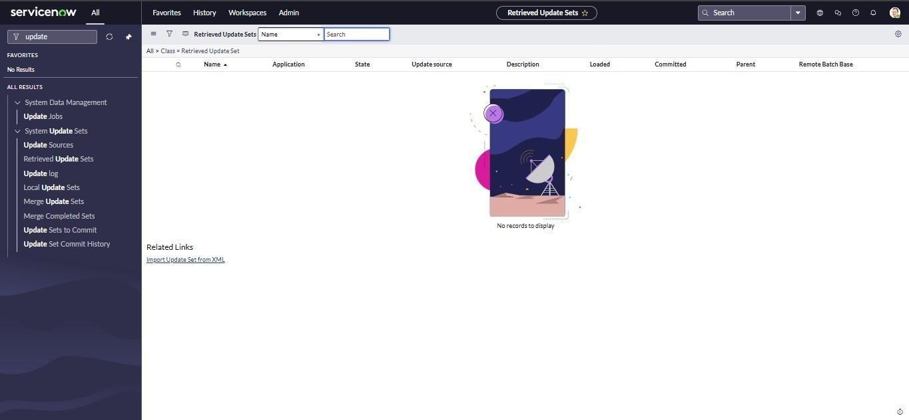

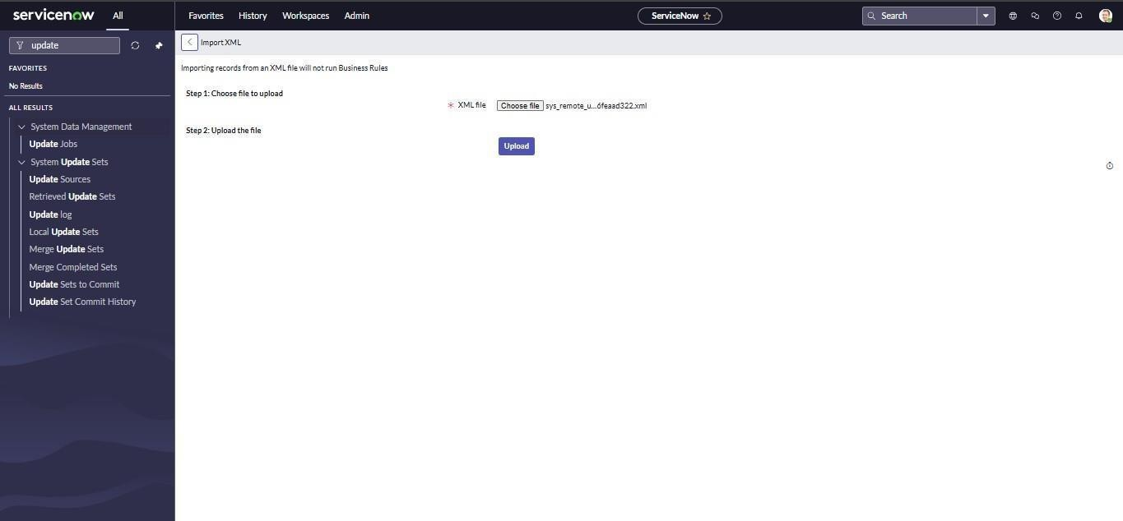

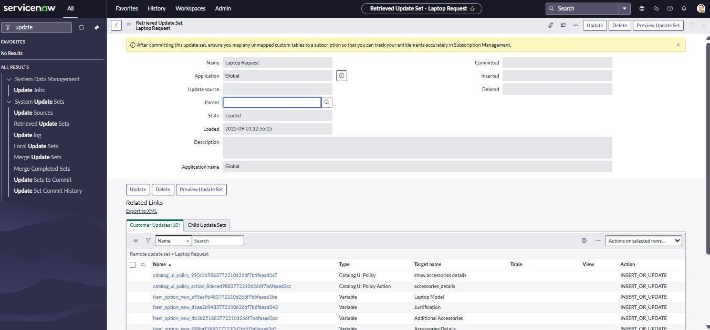

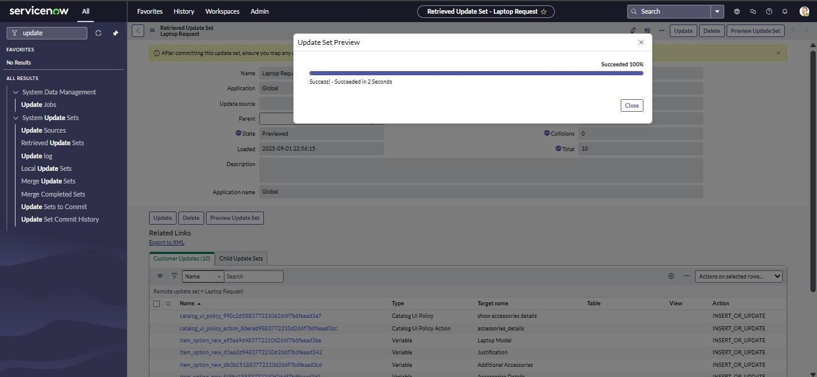

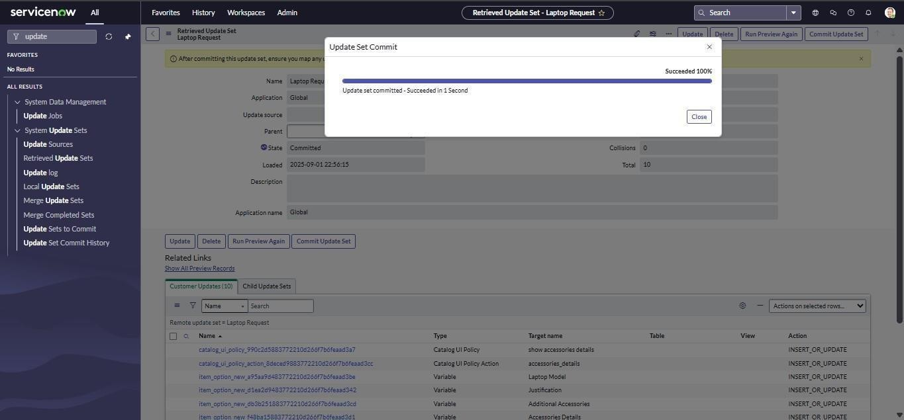

Step7:TesttheCatalog Item

Submitatestrequestand verify:
Workflowtriggers Form behavior
RequestvisibilityinServiceNowportal

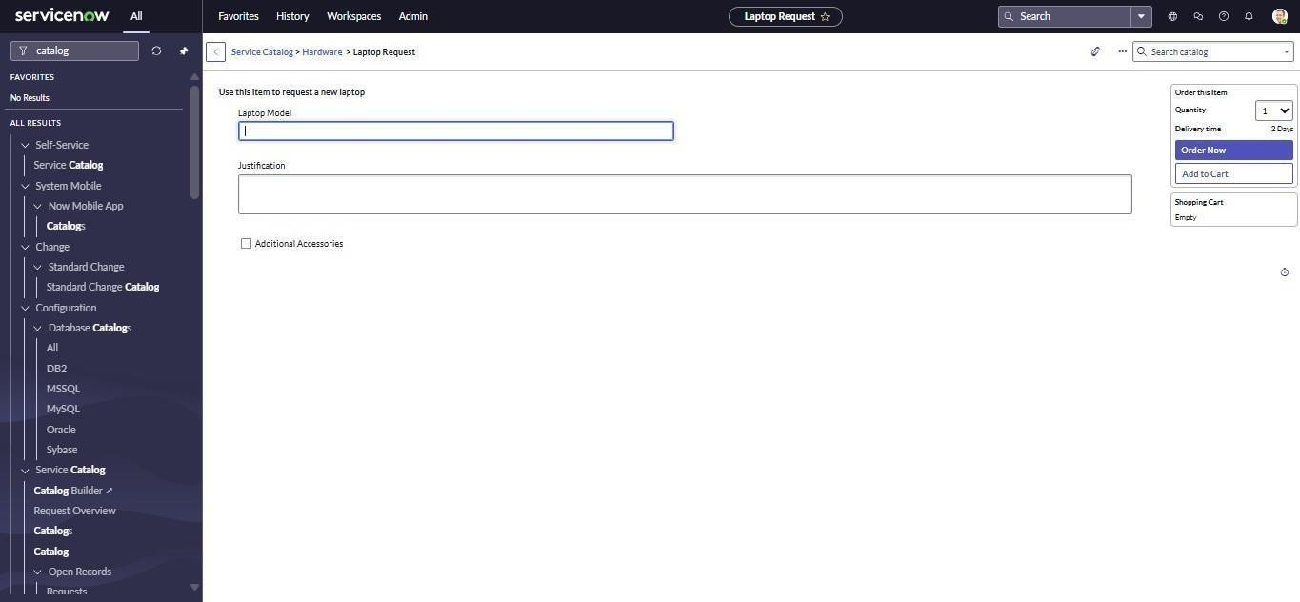

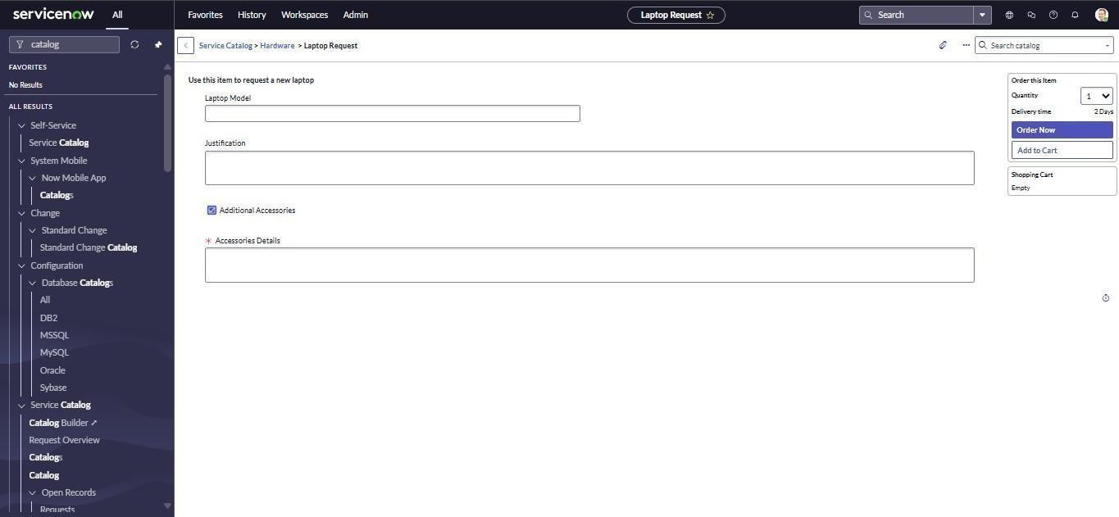

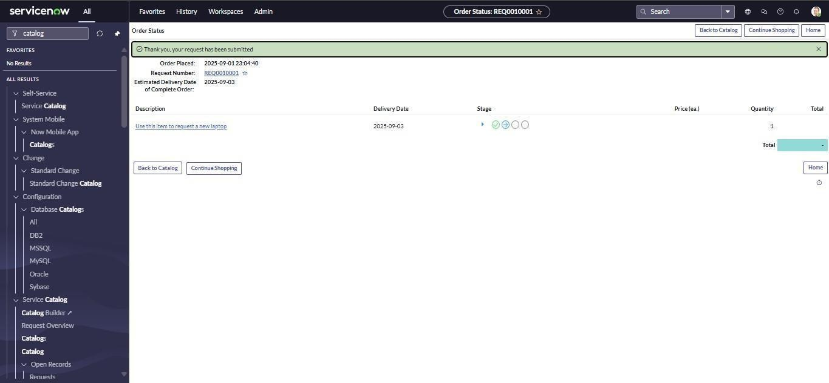

Conclusion
The Laptop Request Catalog Item project successfully automated the laptop request process withinanorganizationusingtheServiceNowplatform.Byreplacingtraditionalmanualmethods withastructureddigitalworkflow,thesolutionsignificantlyimprovedefficiency,accuracy,and user satisfaction.
Through the use of Service Catalog, UI Policies, UI Actions, and Workflow Automation, the project delivered a dynamic and interactive form that simplifies the request and approval process.Employeescannoweasilysubmitrequests,whileITadministratorscantrack,approve, and fulfill them with complete transparency. The inclusion of features such as dynamic fields, form reset functionality, and update set management ensures smooth operation and easy deployment across multiple instances.
Overall, the project demonstrates the power of ServiceNow in automating routine IT service managementtasks,reducinghumanerrors,andenhancingoverallproductivityandgovernance within the organization.

FutureScope
Whilethecurrentimplementationeffectivelyautomateslaptoprequests,thereareseveral potential enhancements that can further extend its functionality:

IntegrationwithAssetManagement:
Connectthecatalogitemwiththeorganization’sassetdatabasetoautomaticallytrack issued laptops and update inventory records.

ApprovalHierarchyCustomization:
Enablemulti-levelapprovalworkflowsbasedonemployeedesignationordepartment.

AutomatedNotificationsandReminders:
Addscheduledremindersandfollow-upnotificationsforpendingapprovalsordelayed requests.

Reportingand Analytics:
Developdashboardstoanalyzerequesttrends,processingtimes,andresourceallocation for better decision-making.

MobileAccessibility:
OptimizethecatalogformformobiledevicesthroughtheServiceNowmobileapp, allowing users to submit requests on the go.

ExpansiontoOtherAssets:
ExtendthesameframeworktomanageotherITassetssuchasmonitors,accessories,and software licenses.
Theseenhancementswillmakethesystemmorecomprehensive,intelligent,andalignedwith evolving organizational IT service management needs.

